Designing and Developing a Reinforcement Learning Based Adaptive Recommendation Engine for News and Current Affairs

CHAPTER 1: INTRODUCTION
1.1 Introduction

In today’s hyperconnected digital world, information flows faster than ever before. With just a smartphone and an internet connection, users are exposed to an endless stream of news from online platforms, including digital newspapers, mobile applications, and social media feeds. The Reuters Institute for the Study of Journalism’s Digital News Reports show that online and social platforms, accessed predominantly through smartphones, have become the main gateway to news in most of the markets surveyed [1], [2]. While this accessibility has democratised information, it has also introduced a critical challenge: information overload [3], [4].
Users are no longer struggling to find news—they are struggling to filter it. The sheer volume of content, ranging from local developments in Lusaka to global geopolitical events, often overwhelms readers. This abundance can lead to cognitive fatigue, reduced engagement, and even exposure to irrelevant or misleading information. The Digital News Report documents a growing share of people who selectively avoid the news, frequently because they find it overwhelming or repetitive, and research on news avoidance identifies information overload as one of its principal causes [1], [5].
To manage this complexity, modern digital platforms increasingly rely on recommendation systems. Companies such as Google, YouTube and Netflix have demonstrated the power of personalisation in enhancing user engagement by tailoring content to individual preferences [6]–[8]. In the context of news, recommendation systems aim to curate articles based on user interests, browsing history, and interaction patterns, thereby improving relevance and user satisfaction [9].
Traditional approaches to recommendation—such as collaborative filtering and content-based filtering—have been widely adopted [10]. However, these methods have inherent limitations. They depend heavily on historical user data and often struggle with cold-start problems (new users or new content), static assumptions about user preferences, and delayed adaptation to emerging trends [11], [12]. This becomes particularly problematic in the news domain, where timeliness and adaptability are critical. News is not static; it evolves minute by minute. A user who typically reads sports news may suddenly seek updates on elections, economic policies, or global crises. For instance, during major global events such as the COVID-19 pandemic, user interest patterns shifted dramatically and unpredictably. Traditional systems often fail to respond effectively to such rapid changes.
This is where Reinforcement Learning (RL) introduces a transformative opportunity. Unlike static recommendation models, RL enables systems to learn continuously through interaction. By modelling the recommendation process as a sequence of decisions, the system can observe user actions (clicks, reading time, shares), receive feedback in the form of rewards or penalties, and adapt its strategy over time to maximise user engagement [13]. Research by DeepMind and others has shown that RL agents can learn effective behaviour directly from interaction in complex environments [14], and RL-based recommenders have been shown to outperform static approaches where user preferences evolve rapidly [15], [16]. Contextual bandit approaches, in particular, have demonstrated effectiveness in personalised news recommendation [17].
In the context of news recommendation, this means moving from a reactive system to a proactive and intelligent system—one that not only understands what users liked in the past but also predicts and adapts to what they need now.
Therefore, this project proposes the design and development of a Reinforcement Learning-based Adaptive News Recommendation Engine. The system aims to deliver personalized, relevant, and timely news content by continuously learning from user behaviour and dynamically adjusting its recommendations. By doing so, it seeks to address the limitations of traditional models and contribute to a more efficient, engaging, and user-centred news consumption experience.
Ultimately, this study is not just about improving recommendation accuracy—it is about reshaping how users interact with information in an era defined by digital overload, ensuring that the right information reaches the right user at the right time [9], [18].

1.2 Problem Statement
Despite the widespread adoption of recommendation systems across digital platforms, many existing news recommendation systems still rely on static or semi-static models that primarily analyse historical user behaviour to generate suggestions. While these systems provide a baseline level of personalisation, they face significant limitations when applied to the dynamic and fast-paced nature of news consumption [9], [19].
One of the most critical challenges is the time-sensitive and rapidly evolving nature of news content. News ecosystems are highly volatile, with topics emerging, trending, and becoming obsolete within short timeframes, so that the useful lifetime of a news item is far shorter than that of a film or product [6], [9]. Audience research likewise shows attention concentrating rapidly on breaking stories [1], highlighting the need for systems that can adapt in near real time. However, traditional recommendation approaches often fail to respond quickly to such changes, resulting in outdated or irrelevant content being recommended, thereby reducing user engagement and satisfaction.
Secondly, conventional recommendation systems tend to reinforce historical user preferences, which can inadvertently create filter bubbles. The concept of filter bubbles, popularised by Eli Pariser, describes how algorithms repeatedly expose users to similar viewpoints, limiting their access to diverse perspectives [20]. Empirical studies of algorithmically ranked social feeds have found that such ranking measurably reduces exposure to cross-cutting news [21], and that algorithmic news consumption is associated with greater ideological segregation [22]. This issue is especially concerning in news systems, where exposure to diverse viewpoints is essential for informed decision-making and civic awareness.
Thirdly, news recommendation systems must address the well-known exploration–exploitation dilemma, a fundamental problem in Reinforcement Learning. The system must strike a balance between:
- Exploitation: recommending familiar content aligned with known user interests
- Exploration: introducing new, diverse, or unexpected content
In the context of news, this balance is crucial. Overemphasis on exploitation leads to repetitive and narrow content delivery, while excessive exploration may reduce relevance and user satisfaction. Research on bandit algorithms shows that strategies which balance this trade-off in a principled way achieve provably lower long-run regret than purely greedy strategies [23], [24], and applied work on news recommendation has shown corresponding gains in click-through and long-term engagement [15], [17].
Furthermore, real-world platforms such as Facebook and YouTube have faced criticism for recommendation algorithms that amplify repetitive or polarising content, and false news has been shown to spread further and faster online than true news [25], [26]. These challenges highlight the broader societal implications of poorly designed recommendation systems.
Without an adaptive and intelligent learning mechanism, existing news recommendation systems are prone to several shortcomings:
- Failure to capture emerging and short-term user interests
- Delivery of repetitive or overly biased content
- Limited exposure to diverse and globally relevant news topics
- Reduced ability to respond to real-time changes in user behaviour and news trends
These limitations underscore the need for a more advanced approach that goes beyond static modelling techniques.
Therefore, there is a strong need for an intelligent, adaptive recommendation system capable of continuously learning from user interactions, dynamically responding to evolving news trends, and maintaining a balance between relevance and diversity.
This project addresses these challenges by proposing the development of a Reinforcement Learning-based Adaptive News Recommendation Engine. By leveraging continuous feedback and real-time learning, the system aims to enhance personalisation, improve adaptability, and promote content diversity, ultimately delivering a more effective and socially responsible news consumption experience [16], [17].

1.3 Aim and Objectives
To design and implement a reinforcement learning-based adaptive recommendation engine for news and current affairs that improves personalization, adaptability, and relevance of recommended content.

1. To analyse the limitations of existing news recommendation techniques in handling dynamic and real-time content.
2. To design and develop a reinforcement learning model that adapts to user interactions and evolving interests in both local and international news.
3. To evaluate the effectiveness of the proposed system in terms of accuracy, user engagement, and diversity of recommended content.

1.4 Research Questions
How can a reinforcement learning-based adaptive recommendation engine improve the personalization and effectiveness of news and current affairs recommendations compared to traditional systems?
1. What are the limitations of existing news recommendation systems in handling dynamic and real-time content?
2. How can reinforcement learning be applied to adapt recommendations based on evolving user interests in local and international news?
3. How effective is the proposed system in improving recommendation accuracy, user engagement, and content diversity?

1.5 Scope and Limitations
This study focuses on the design and development of an adaptive recommendation engine tailored for news and current affairs, with particular emphasis on both local Zambian and international news content. The research explores existing recommendation approaches and examines their suitability within the dynamic context of news delivery. It involves the development of a reinforcement learning model capable of adapting to user interactions such as clicks, reading time, explicit likes and dislikes, and stated interests. The system integrates six news categories—politics, economics, technology, global affairs, sports, and health—drawn live from international outlets and Zambian news sources, to ensure a comprehensive recommendation space. A prototype of the system is implemented using Python and relevant machine learning libraries, and its performance is evaluated based on key metrics such as recommendation accuracy, user engagement, and diversity of content presented to users.

However, the study is subject to several limitations that may influence the generalizability and practical application of the findings. Access to large-scale, real-time user interaction data is constrained, which necessitates the use of simulated or limited datasets for training and evaluation. Additionally, the highly dynamic and rapidly evolving nature of news content presents challenges in fully capturing real-world behaviour within a controlled experimental environment. The computational demands of reinforcement learning models may also limit the complexity and scale of the implementation. Furthermore, the system developed in this study is a prototype and is not deployed at a commercial or production level, meaning that its performance is tested in a controlled setting rather than within a live news platform. These constraints may affect the extent to which the system reflects real-world conditions and user behaviour.

1.6 Significance of the Study
This study is significant in addressing the growing challenge of information overload in modern news consumption, a problem that has become increasingly prevalent with the rapid expansion of digital media platforms. In today’s information-driven society, users are constantly exposed to an overwhelming volume of news from multiple sources, including online news portals, mobile applications, and social media platforms. While this accessibility has improved the availability of information, it has also made it more difficult for individuals to identify relevant, timely, and credible news content. As a result, users often experience fatigue, reduced engagement, or even complete avoidance of news consumption. This study seeks to contribute a meaningful solution to this problem by developing an adaptive recommendation system capable of intelligently filtering and personalizing news content in real time.

From an academic perspective, this research contributes to the growing body of knowledge in the field of Reinforcement Learning and its application in dynamic environments. While traditional recommendation systems such as collaborative filtering and content-based filtering have been widely studied, their limitations in handling rapidly changing user preferences and time-sensitive data highlight the need for more advanced approaches. This study extends existing research by exploring how reinforcement learning techniques can be effectively applied to the domain of news recommendation, where both user interests and content evolve continuously. By doing so, it provides a foundation for future researchers to build upon, particularly in areas involving real-time personalization, adaptive systems, and intelligent decision-making models.

In terms of technological contribution, the study demonstrates the practical implementation of an adaptive recommendation engine that leverages continuous learning from user interactions. Unlike conventional systems that rely heavily on static historical data, the proposed model dynamically adjusts its recommendations based on real-time feedback such as user clicks, reading duration, and engagement patterns. This approach reflects modern trends in intelligent system design, as seen in leading technology companies such as Google and Netflix, where adaptive algorithms play a central role in enhancing user experience. By showcasing how reinforcement learning can be applied within the context of news systems, this study highlights the potential for more responsive, efficient, and user-centred technologies in digital content delivery.

Practically, the findings of this study have direct implications for improving user experience on news platforms. By providing personalized and relevant content, the proposed system can help users navigate large volumes of information more efficiently, reducing the time and effort required to find meaningful news. Additionally, by incorporating both local and international news sources, the system ensures that users are not only exposed to content that aligns with their interests but are also kept informed about broader global developments. This is particularly important in contexts such as Zambia, where access to balanced and diverse information can support greater awareness of both national and international issues. Furthermore, by reducing repetitive recommendations and introducing diverse content, the system addresses the problem of filter bubbles, thereby enhancing the overall quality and depth of news consumption.

The study also carries significant social implications. In an era where misinformation and biased content can easily spread through digital platforms, the ability to deliver accurate, relevant, and diverse news is crucial. By promoting exposure to a wider range of topics and perspectives, the proposed system can contribute to more informed and critical thinking among users. Access to well-curated information enables individuals to make better decisions in areas such as politics, economics, and social development. Moreover, by encouraging engagement with credible and varied news sources, the system supports the development of a more informed and aware society, which is essential for democratic participation and national development.

Another important aspect of this study is its contribution to addressing the exploration–exploitation challenge inherent in recommendation systems. By utilizing reinforcement learning, the system is able to balance the need to recommend familiar content that aligns with user preferences while also introducing new and diverse topics. This balance is critical in ensuring that users remain engaged without being confined to narrow information spaces. As such, the study not only improves technical performance but also enhances the ethical and societal value of recommendation systems by promoting diversity and inclusivity in information access.

Finally, this research is valuable for developers, researchers, and organizations seeking to build more intelligent and adaptive systems. It provides a practical framework for designing recommendation engines that can operate effectively in dynamic environments, offering insights into system architecture, data handling, and performance evaluation. The prototype developed in this study serves as a proof of concept that can be further expanded and refined for real-world applications. In doing so, it bridges the gap between theoretical research and practical implementation, making it a useful reference for future innovations in the field of intelligent systems.

1.7 Conceptual Framework
start

User interface layer
Data collection and tracking
interactions

recommendations structured data
Reactions
Data storage
Feedback loop

Data processing and feature engineering

Recommendation Engine

features
Reinforcement learning model

End

figure 1: conceptual framework
The conceptual framework of this study illustrates how the proposed system intelligently delivers personalized news recommendations by continuously learning from user interactions.
The conceptual framework of this study explains how the proposed system delivers personalized news recommendations through a continuous learning process driven by user interaction. At its foundation is the input layer, which captures data from both user behaviour—such as clicks, reading time, and preferences—and news content features like topics and categories. This data is then processed by the reinforcement learning (RL) model, which acts as the intelligent decision-maker of the system. The RL model interacts with the environment by selecting news articles to recommend and continuously evaluates its decisions based on user responses. Using the insights generated by this learning process, the recommendation engine produces a tailored list of news articles that align with the user’s interests. A key component of the framework is the feedback mechanism, which enables the system to learn from user engagement by treating interactions as rewards or penalties. This creates a continuous improvement loop, allowing the system to refine its recommendations over time. Ultimately, the output layer delivers a stream of personalized, adaptive, and diverse news content, ensuring that the recommendations become increasingly accurate, relevant, and responsive to changing user preferences.

1.8 Organisation of the Report
This report is structured into four chapters, each carefully designed to guide the reader from foundational concepts to the system's design and current development progress.

Chapter One: Introduction
This chapter provides the background and context of the study, focusing on the challenges of news consumption in the digital age. It introduces recommendation systems and highlights the need for adaptive solutions in handling dynamic news content. The chapter also outlines the problem statement, objectives, research questions, scope, significance, and conceptual framework of the study.

Chapter Two: Literature Review
This chapter critically examines existing research on recommendation systems, with particular emphasis on news recommender systems. It explores traditional techniques such as collaborative filtering and content-based filtering, as well as hybrid approaches. Additionally, it reviews the application of reinforcement learning in recommendation systems and identifies gaps that justify the need for this study.

Chapter Three: Research Methodology
This chapter explains the methods and approaches used in conducting this research. It describes the research design, data collection methods (real or simulated user interactions) tools and technologies used (e.g. python, machine learning libraries), and the reinforcement learning approach adopted. It also outlines how the system’s performance will be evaluated.

Chapter Four: System Design and Development
This chapter presents both the design and the current development progress of the proposed system. It includes system architecture diagrams, the structure of the reinforcement learning model, and the interaction between the user interface, backend, database, and recommendation engine, and it reports the extent to which each of these components has been implemented and evaluated at the time of writing.

1.9 Summary
This chapter has established the foundation for the study by exploring the growing challenges associated with modern news consumption and the need for more intelligent and adaptive recommendation systems. In an era where digital platforms dominate information access, users are increasingly overwhelmed by the sheer volume of available content. Reports from the Reuters Institute for the Study of Journalism indicate that a majority of users now rely on online sources for news, yet many struggle to find content that is both relevant and timely. This highlights a critical gap between information availability and effective information delivery.
The chapter identified key limitations of traditional recommendation systems, particularly their reliance on historical data and their inability to adapt quickly to the dynamic nature of news. Real-world platforms such as Facebook and YouTube have demonstrated both the power and the risks of algorithm-driven recommendations, including the creation of filter bubbles and the amplification of repetitive or biased content. These challenges reinforce the need for systems that not only personalize content but also promote diversity and adaptability in information delivery.
To address these issues, the chapter introduced Reinforcement Learning as a suitable approach for building adaptive recommendation systems. Unlike traditional models, reinforcement learning enables continuous learning through user interaction, allowing systems to respond dynamically to changing user interests and emerging news trends. The relevance of such adaptive systems is evident in modern AI research and applications by organizations such as DeepMind, where learning from real-time feedback has significantly improved decision-making in complex environments.
The objectives and research questions were carefully aligned to focus on analysing existing limitations, developing an adaptive reinforcement learning model, and evaluating its effectiveness in improving accuracy, engagement, and content diversity. The scope of the study clarified that the project will concentrate on a prototype system integrating both local and international news, while the limitations acknowledged constraints such as data availability, computational resources, and controlled testing environments.
Furthermore, the significance of the study was emphasized from multiple perspectives. Academically, it contributes to advancing research in adaptive recommendation systems. Technologically, it demonstrates how intelligent models can enhance real-time personalization. Practically and socially, it addresses issues such as information overload, limited content diversity, and user disengagement, while promoting informed decision-making through access to relevant and diverse news content.

CHAPTER 2: LITERATURE REVIEW

2.1 Introduction
The rapid expansion of digital technologies has fundamentally transformed how information is produced, distributed, and consumed across virtually every domain of modern life. In the context of news and current affairs, online platforms have become the primary source of information for a large and growing proportion of the global population [1], [27]. Social media networks, digital news aggregators and content sharing applications have displaced traditional media as the dominant channels through which people stay informed about local, national and global events. This transformation has not only changed the speed at which information travels but has also redefined the nature of audience engagement, shifting from passive consumption to interactive and participatory models where users actively curate, share and respond to content.
While this shift has improved accessibility, it has also introduced the challenge of information overload, where users are exposed to vast amounts of content, making it increasingly difficult to identify relevant and meaningful information [3], [4].
To address this challenge, recommendation systems have emerged as essential tools for filtering and personalizing content. These systems aim to enhance user experience by delivering relevant information based on user preferences and behaviour. However, the dynamic nature of news—characterized by rapidly changing topics and evolving user interests—poses significant challenges for traditional recommendation approaches.
This chapter reviews existing research on recommendation systems, focusing on their application in news platforms. It explores related works, critically analyses existing approaches, and identifies gaps that justify the need for a reinforcement learning-based adaptive recommendation system.

Digital platforms vs Massive real-time
Volume
Traditional media

Information overload
Social platforms
Television
Filter bubbles
News aggregators
Radio

Misinformation risk
Content platforms
News papers

Figure 2: media transition

The diagram above illustrates the structural shift from traditional, volume-constrained media to digital platforms characterized by both opportunity and challenge. In addition to volume, the velocity and variety of news content further complicate user experience. News is inherently dynamic, with topics evolving rapidly and user interests shifting based on current events, personal circumstances, and societal trends. A story that is highly relevant at one moment may quickly lose significance as new developments emerge. This temporal sensitivity distinguishes news recommendation from other domains such as e-commerce or entertainment, where user preferences tend to remain relatively stable over time. Consequently, systems designed for news delivery must not only filter large volumes of information but also adapt continuously to changing user behaviors and contextual factors.

The Role of Recommendation Systems
To address the challenge of information overload, recommendation systems have emerged as essential tools for filtering and personalising digital content. These systems aim to enhance the user experience by delivering content that is relevant to individual preferences, behavioural patterns, and contextual needs — effectively acting as intelligent intermediaries between the user and an otherwise unmanageable content space. By analysing user interactions such as clicks, reading time, likes, and sharing behaviour, recommendation systems can infer implicit preferences and tailor content accordingly. This not only improves user satisfaction but also increases engagement, retention, and overall platform efficiency [10], [28].

Recommendation systems can be broadly classified into three major paradigms:
Collaborative filtering leverages the behavioural similarities between users, recommending items that users with similar histories have engaged with; the idea was pioneered by the Tapestry and GroupLens systems, the latter applied to Usenet news [29], [30]. While effective in many domains, this approach suffers from the cold-start problem — its inability to make meaningful recommendations for new users or new articles due to insufficient historical data [11]. Additionally, collaborative filtering may struggle in fast-changing environments like news platforms, where new content is constantly being generated and user interests evolve rapidly, limiting the usefulness of past interaction data [6].

Content-based filtering analyses the attributes of items themselves (such as topic, keywords, or writing style) and matches them to known user preferences [31]. Although less dependent on historical data, this approach tends to over-specialise, repeatedly recommending content similar to what the user has already consumed, thereby limiting exposure to diverse perspectives. This phenomenon, often referred to as the "filter bubble," can reduce informational diversity and hinder users from accessing a balanced range of viewpoints, which is particularly problematic in the context of news consumption [20].

Hybrid approaches combine the strengths of both paradigms, often improving recommendation quality [32]. However, they introduce greater architectural complexity and may still fail to capture the temporal dynamics characteristic of news environments. Moreover, traditional hybrid systems are typically static in nature, relying on predefined rules or weights, which limits their ability to adapt in real time to evolving user behaviour and rapidly changing content landscapes.

Recommendation systems for news systems

Hybrid
Content based
collaborative

Static model: Miss temporary drift
Over specialization: Limits diversity
Cold start: New User

2.2 Related Works

Recommendation systems have been widely studied and implemented across various domains, including e-commerce, entertainment, and social media [10], [28]. Early approaches were primarily based on collaborative filtering and content-based filtering techniques. Collaborative filtering, as discussed by Koren et al., leverages user interaction data to identify patterns and recommend items based on similarities between users or items [33]. This approach has been successfully applied in platforms such as Netflix, where it significantly improves user engagement through personalised recommendations [8]. By analysing historical interactions such as ratings, clicks and viewing history, collaborative filtering is able to uncover latent relationships between users and items, often using matrix factorisation techniques to model these relationships. However, despite its effectiveness, the method faces several well-documented limitations, including sparsity of data, scalability challenges in large systems, and its dependence on sufficient historical interaction data to generate meaningful recommendations.
Content-based filtering, on the other hand, focuses on item attributes, recommending content that is similar to what users have previously consumed. This method typically relies on techniques such as term frequency–inverse document frequency (TF-IDF) weighting and cosine similarity [34], [35], or more advanced natural language processing approaches, to represent content features; early adaptive news systems combined such representations with short- and long-term models of each reader [36]. While effective in certain contexts, this approach tends to limit diversity by repeatedly suggesting similar items, thereby restricting user exposure to new information. Over time, this can lead to reduced novelty and user fatigue, particularly in dynamic domains like news where exposure to a variety of perspectives is essential.
Hybrid recommendation systems were later introduced to combine the strengths of both approaches [32]. These systems improve recommendation accuracy by integrating user behaviour and content features, often through weighted combinations, switching strategies, or more complex model-based integrations. Google News, for example, combined collaborative signals with click-behaviour-based profiles of each user's topical interests [6], [37]. However, hybrid systems still rely heavily on historical data and often fail to adapt to rapidly changing environments such as news platforms, and they can become computationally expensive and complex to maintain when scaling to millions of users and continuously updated content streams.
Recent advancements have seen the integration of deep learning techniques into recommendation systems [38]. Covington et al. demonstrated the use of deep neural networks in large-scale recommendation at YouTube, using a two-stage framework of candidate generation and ranking trained on massive interaction datasets [7]. This marked a significant shift from traditional methods toward representation learning, enabling systems to learn complex, non-linear relationships in data. Similarly, embedding-based methods have been applied to news recommendation, representing users and articles in a shared feature space for improved matching [39], and knowledge-aware models have enriched article representations with entities drawn from knowledge graphs [40].
A significant contribution to neural news recommendation was made by Wu et al., who proposed the NRMS model, a neural news recommendation approach based on multi-head self-attention [41]. Its news encoder learns article representations from titles by modelling interactions between words, while its user encoder captures relationships between the articles a user has previously browsed. Related models learn separate long- and short-term user representations [42], apply personalised attention [43], or initialise the news encoder with pre-trained language models [44]. To support benchmark evaluation of such systems, Wu et al. introduced the MIND dataset, constructed from the click logs of Microsoft News, which contains one million users and more than 160,000 English news articles and has become a standard benchmark for the field [45]. Comprehensive surveys of these methods and of the challenges specific to news are provided in [9], [18], [19].
One of the most influential early works in applying reinforcement learning ideas directly to the news domain is the contextual bandit framework proposed by Li et al. [17]. This work modelled personalised recommendation of news articles as a contextual bandit problem, in which a learning algorithm sequentially selects articles to serve users based on contextual information while adapting its article-selection strategy from user-click feedback in order to maximise total clicks. Evaluated on more than 33 million events from the Yahoo! Today Module, the LinUCB algorithm achieved a 12.5% click lift over a context-free bandit algorithm, demonstrating the advantage of context-aware, adaptive selection strategies and highlighting the importance of balancing exploration and exploitation.
Building on this, Zheng et al. proposed DRN, a deep reinforcement learning framework specifically for news recommendation [15]. DRN addresses three issues in online news recommendation: modelling only the current reward, neglecting user feedback beyond click or no-click labels, and the tendency to keep recommending similar content. It uses a Deep Q-Network that models both immediate and future rewards, incorporates user return frequency as an additional feedback signal, and uses a dueling bandit gradient descent exploration strategy to balance personalisation with diversity.
In addition to these approaches, research has explored sequential and session-based recommendation models, which capture the order and temporal dependencies of user interactions [46]. Recurrent and self-attentive architectures have been applied to model user behaviour over time [42], [47], enabling systems to better track evolving preferences. Despite these advancements, many existing systems remain limited in their ability to handle real-time changes in user preferences and content dynamics. Most traditional and even many deep learning-based models are trained offline and updated periodically rather than continuously, creating a gap between user behaviour and system response. As a result, there is a growing need for adaptive learning approaches, such as reinforcement learning, that can update their strategies from immediate feedback and long-term engagement patterns.
2.2.1 Reinforcement Learning and Bandit Foundations
Reinforcement learning formalises the problem of an agent that learns, by trial and error, to choose actions that maximise cumulative reward from its environment [13]. Policy-gradient methods learn a parameterised policy directly by following the gradient of expected reward, a family that originates with the REINFORCE algorithm [48] and includes Proximal Policy Optimization (PPO), which stabilises learning by limiting the size of each policy update [49]. Combined with deep neural networks, such methods have achieved human-level performance in complex sequential tasks [14].
The multi-armed bandit is the simplest setting in which the exploration–exploitation dilemma arises: at each round the learner chooses one of several arms and observes only that arm's reward. Classical strategies include Thompson sampling, which samples each arm in proportion to its posterior probability of being best [50], [51], and upper-confidence-bound methods with finite-time regret guarantees [23]. Contextual bandits extend this setting by letting the learner observe side information, such as a user profile, before each choice [24]; because they ignore state transitions they are far more sample-efficient than full reinforcement learning, which makes them well suited to recommendation where each impression is largely independent. Li et al. also showed that bandit policies can be evaluated without bias from logged random-exploration data, which made offline comparison of news recommenders practical [52].
2.2.2 Deep Reinforcement Learning for Recommendation
Beyond bandits, a growing body of work treats recommendation as a full Markov decision process. Zhao et al. used deep reinforcement learning with both positive and negative feedback to learn recommendation policies [53]; Chen et al. deployed a REINFORCE-based recommender at YouTube scale with an off-policy correction for learning from logged data [54]; Ie et al. proposed SlateQ, which decomposes the value of a whole slate of recommendations into tractable item-level values [55]; and Zou et al. optimised long-term user engagement rather than immediate clicks [56]. Recent surveys catalogue these methods and identify recurring open problems, including the cost of exploration on real users, the reliance on simulators for training, and the difficulty of offline evaluation [16], [57], [58]. These open problems directly shape the present study, which uses a simulator for training and evaluates offline before any live deployment.
2.2.3 Cold Start and Preference Elicitation
New readers present a cold-start problem for every learning-based recommender, since there is no history from which to infer preferences [11]. A common remedy is to ask new users to state some preferences at sign-up: Rashid et al. showed that the choice of which items to ask about strongly affects how quickly a recommender learns a new user's tastes [59], and active-learning approaches select elicitation questions to maximise the information gained [60]. The design adopted in this study (Section 4.7.1) follows this line of work by treating stated interests as a prior that is gradually overridden by observed behaviour, analogous to an informative prior in Thompson sampling [51].
2.2.4 Implicit and Explicit Feedback
Recommenders learn from two kinds of feedback. Implicit feedback, such as clicks and reading time, is plentiful but ambiguous: a click may reflect curiosity rather than satisfaction, and a short read may reflect a short article [61]. Dwell time has nevertheless been shown to be a more reliable signal of satisfaction than clicks alone [62], and click behaviour has been used successfully to model the evolving interests of news readers [37]. Explicit feedback, such as ratings, likes and dislikes, is sparser but less ambiguous, and frameworks combining both kinds of signal have been proposed [63]. Negative feedback in particular carries information that click-only models discard [53]. This motivates the hybrid reward used in this study, which combines clicks, dwell time and explicit likes and dislikes (Sections 4.8 and 4.9.1).
2.2.5 Diversity, Filter Bubbles and Exposure
The risk that personalisation narrows what people see has been examined empirically as well as conceptually. Nguyen et al. found that users who followed recommendations experienced a slower narrowing of content diversity than those who did not [64], and Möller et al. found that some recommendation logics can produce more diverse news exposure than human editors [65]; Zuiderveen Borgesius et al. conclude that the evidence for strong filter-bubble effects is limited but that the concern justifies continued attention [66]. Simulation studies show that recommenders trained on data their own recommendations generated can homogenise user behaviour over time [67], a feedback loop directly relevant to an adaptive system. Helberger et al. argue that exposure diversity should be treated as an explicit design principle for news recommenders [68]. Practical techniques include topic diversification of recommendation lists [69], maximal marginal relevance re-ranking [70], and beyond-accuracy objectives such as novelty, serendipity and coverage [71].
2.2.6 Evaluating News Recommenders
Recommender evaluation traditionally relies on offline accuracy metrics such as precision, recall and mean absolute error [72], together with rank-sensitive measures such as normalised discounted cumulative gain [35], [73]. For news, offline accuracy is an incomplete guide, because articles age quickly and because the recommender itself shapes the data on which it is later evaluated [9], [19]. Online controlled experiments (A/B tests) remain the most reliable way to measure the effect of a recommender on real users [74], while replay-based offline evaluation offers an unbiased alternative for bandit policies when randomised logs are available [52].
2.2.7 Search, Story Detection and Summarisation in News Applications
News applications typically complement recommendation with search and summarisation. Keyword search relies on term normalisation such as stemming [75] and on relevance ranking functions such as those of the probabilistic relevance framework [76]. Detecting emerging or trending stories from a stream of documents has been studied as burst detection [77]. Automatic summarisation has a long history, from Luhn's frequency-based extraction of salient sentences [78] to graph-based centrality methods such as LexRank and TextRank [79], [80]; surveys distinguish these extractive approaches from abstractive methods that generate new text [81]. Abstractive summaries produced by neural language models are fluent but can contain statements not supported by their sources [82], [83], which motivates the hybrid design adopted in this study (Section 4.10.3). Extracting the main text of a news page from its surrounding navigation and advertising is itself a non-trivial step, for which tools such as Trafilatura have been developed [84].
2.3 Review of Related Works
A critical analysis of existing literature reveals several limitations in current recommendation approaches. Traditional systems, including collaborative and content-based filtering, operate under the assumption that user preferences remain relatively stable over time [12]. However, this assumption does not hold in the context of news consumption, where user interests can change rapidly in response to emerging events [9].

The table presents a structured comparison of key studies related to news recommendation systems, highlighting their contributions and limitations. It also identifies existing gaps in current approaches and demonstrates how the proposed reinforcement learning-based system aims to address these challenges.

Table 2.3.1: Comparative Analysis of Existing News Recommendation Approaches and Identified Research Gaps

Author(s) | Title | What Was Done | Gap Identified | Proposed System Contribution
Bawden & Robinson [3] | The Dark Side of Information: Overload, Anxiety and Other Paradoxes and Pathologies | Examined the effects of excessive information on users, highlighting cognitive overload and reduced decision-making efficiency | Does not provide a technical solution for filtering or personalisation of content | Introduces an intelligent recommendation engine that filters and prioritises relevant news to reduce information overload
Eppler & Mengis [4] | The Concept of Information Overload | Reviewed how large volumes of information negatively affect decision quality and productivity across disciplines | Lacks implementation of adaptive systems to manage information flow dynamically | Uses reinforcement learning to continuously adapt and present manageable, relevant news content
Pariser [20] | The Filter Bubble | Argued that algorithmic personalisation limits exposure to diverse viewpoints | Does not propose mechanisms to balance personalisation with diversity | Incorporates exploration, a diversity floor and discovery slots to expose users to diverse news content
Walker & Matsa, Pew Research Center [27] | News Consumption Across Social Media in 2021 | Surveyed how adults obtain news through algorithmically curated social media platforms | Descriptive; offers no mechanism for improving the relevance or diversity of what users are shown | Designs a system that balances personalisation and diversity using reinforcement learning policies
Sutton & Barto [13] | Reinforcement Learning: An Introduction | Defined the reinforcement learning framework and the exploration–exploitation trade-off | Does not directly apply concepts to real-world news recommendation systems | Applies RL theory to dynamically balance exploration (new content) and exploitation (user preferences)
Li et al. [17] | A Contextual-Bandit Approach to Personalized News Article Recommendation | Developed the LinUCB contextual bandit and showed a 12.5% click lift on Yahoo! news data | Linear payoff model; assumes a large stream of anonymous traffic and does not address explicit preferences or local news | Applies a neural contextual-bandit policy to local and international news, with stated interests and explicit feedback
Zheng et al. [15] | DRN: A Deep Reinforcement Learning Framework for News Recommendation | Used a Deep Q-Network with user-return signals and dueling-bandit exploration for news | Requires large-scale industrial interaction logs and substantial computation | Uses a lightweight bandit formulation trainable on simulated data, suitable for a resource-constrained setting
Wu et al. [41], [45] | Neural News Recommendation with Multi-Head Self-Attention; MIND | Proposed attention-based neural news encoders and the MIND benchmark dataset | Models are trained offline and updated periodically rather than adapting continuously | Adapts each reader's feed on every interaction without retraining
Mnih et al. (DeepMind) [14] | Human-level Control through Deep Reinforcement Learning | Demonstrated deep RL learning effective behaviour directly from interaction in complex environments | Not specifically tailored to news recommendation systems | Adapts RL techniques specifically for real-time news recommendation and user behaviour modelling

However, these approaches are still evolving, and their application in real-world news systems remains limited.
Overall, the literature highlights a clear gap in the development of adaptive recommendation systems capable of learning continuously and responding to real-time changes in user behaviour and content.

2.4 Proposed Approach
Based on the identified gaps, this study proposes a reinforcement learning-based adaptive recommendation system designed specifically for news and current affairs. Unlike traditional approaches, the proposed system treats recommendation as a sequential decision-making process, where the system continuously interacts with users and updates its strategy based on feedback.
The system utilises a contextual bandit framework, which allows it to consider both user context and content features when making recommendations. By observing user interactions such as clicks and reading time, the system receives feedback in the form of rewards, enabling it to learn and improve over time [17], [24].
This approach addresses the limitations of traditional systems in several ways. First, it enables real-time adaptation, allowing the system to respond quickly to changes in user interests and news trends. Second, it incorporates mechanisms for balancing exploration and exploitation, ensuring that users are exposed to both relevant and diverse content. Third, it reduces reliance on static historical data by continuously updating its learning model.
By integrating reinforcement learning into the recommendation process, the proposed system aims to deliver more accurate, dynamic, and socially responsible news recommendations.

2.5 System Overview
The proposed system is designed as an adaptive framework consisting of multiple interconnected components that work together to deliver personalized news recommendations. The process begins with data collection, where user interactions and news content features are captured and processed. This information is then fed into the reinforcement learning model, which serves as the core decision-making component of the system.
The model evaluates different recommendation strategies and selects the most appropriate articles based on learned policies. The recommendation engine then presents these articles to the user, and their interactions provide feedback that is used to update the model. This creates a continuous learning loop, enabling the system to improve its performance over time.
In summary, this chapter has examined existing research on recommendation systems and identified key limitations in traditional approaches, particularly in the context of dynamic news environments. It has demonstrated that while significant progress has been made, current systems still struggle with adaptability, diversity, and real-time responsiveness. The proposed reinforcement learning-based approach addresses these challenges by introducing a continuous learning mechanism that enhances personalization while maintaining content diversity. This provides a strong foundation for the system design and implementation presented in the next chapter.

CHAPTER 3: METHODOLOGY
3.1 Introduction
This chapter presents the methodology adopted in the design and development of the reinforcement learning-based adaptive recommendation engine for news and current affairs. The methodology provides a structured framework that ensures the system is developed in a systematic, efficient, and scientifically grounded manner. Given the data-intensive and intelligent nature of the proposed system, it is essential to adopt a methodology that supports iterative learning, data processing, and continuous improvement.
The development of modern recommendation systems has increasingly relied on data mining and machine learning methodologies that allow systems to adapt dynamically to user behavior. In this context, the CRISP-DM framework was selected due to its flexibility, iterative structure, and strong alignment with data-driven system development. This chapter further discusses the requirements specification process, including stakeholder identification, requirements gathering, analysis, and validation, ensuring that the system meets both user and technical expectations.

3.2 Software Development Methodology
The CRISP-DM methodology is a widely accepted standard for developing data mining and intelligent systems [85]. It consists of six iterative phases that guide the development process from problem understanding to deployment. Unlike traditional linear models, CRISP-DM supports continuous feedback and refinement, making it particularly suitable for reinforcement learning-based systems where adaptation is essential, and a systematic review of its application confirms that it remains the de facto standard for data-science projects [86].

Figure 3.1: CRISP-DM Lifecycle [87]

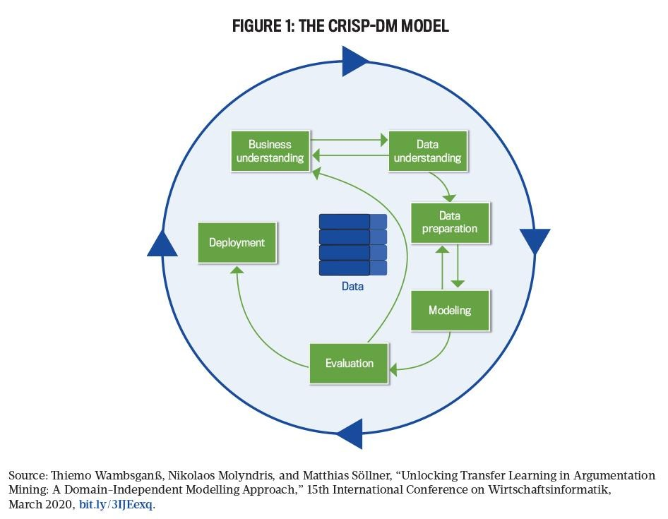
The first phase, business understanding, focuses on defining the objectives of the system from a user and organisational perspective. In this study, the primary goal is to address the challenge of information overload by delivering personalised and relevant news content. This aligns with research showing that users are increasingly overwhelmed by the volume of online information, necessitating intelligent filtering systems [1], [4].
The data understanding phase involves collecting and exploring datasets related to user interactions and news content. This includes analysing user clicks, reading duration, and content categories to identify behavioural patterns, since implicit signals such as clicks and dwell time are known to carry useful, if noisy, evidence of preference [61], [62]. Such insights are critical for building adaptive models that can learn user preferences effectively.
Following this, the data preparation phase ensures that raw data is cleaned, transformed, and structured appropriately. This step is crucial in machine learning systems, as poor data quality can significantly affect model performance. Techniques such as normalisation, feature extraction, and encoding are applied to prepare the dataset for modelling [85].
In the modelling phase, reinforcement learning techniques are implemented to enable the system to learn dynamically from user interactions. The system continuously updates its recommendation strategy based on rewards derived from user engagement, such as clicks and reading time. This approach has been shown to outperform static recommendation models in dynamic environments [13], [15], [17].
The evaluation phase assesses the effectiveness of the model using performance metrics such as accuracy, precision, ranking quality and user engagement rates [72], [73]. The system is tested to ensure that it meets the defined objectives and delivers meaningful recommendations. Finally, the deployment phase involves integrating the system into a user-facing platform, allowing real-time interaction and continuous learning.

3.3 Requirements Specification
Requirements specification is a critical process that defines the expected functionality and constraints of the system. It ensures that all stakeholders share a common understanding of what the system is intended to achieve. This process involves identifying stakeholders, gathering requirements, analyzing them, and validating their feasibility.
3.3.1 Stakeholder Identification
Stakeholders are individuals or groups with an interest in the system. In this project, the primary stakeholders include end users who interact with the recommendation system, system administrators responsible for maintenance, developers who design and implement the system, and content providers who supply news data. Each stakeholder group plays a significant role in shaping the system requirements and ensuring its success.
3.3.2 Requirements Gathering
Requirements were gathered using multiple techniques to ensure completeness and accuracy. A comprehensive literature review was conducted to understand existing systems and identify their limitations. Additionally, user surveys and informal interviews were used to capture user expectations and preferences. Observational studies of existing news platforms further provided insights into user behaviour and interaction patterns. These methods collectively ensured that the system requirements are both user-centred and technically feasible [88].
3.3.3 Requirements Analysis
The gathered requirements were analysed to ensure consistency, feasibility, and alignment with project objectives. This process involved organising requirements into meaningful categories and identifying dependencies among system components. The analysis also helped prioritise critical features such as personalisation and adaptability, which are central to the system’s success. Proper requirements analysis reduces ambiguity and ensures a clear roadmap for system development [88].
3.3.4 Functional and Non-Functional Requirements
The functional requirements define the core operations of the system. The system is expected to collect user interaction data, analyze behavioral patterns, and generate personalized recommendations. It must also allow users to interact with recommended content and continuously adapt based on feedback. Administrative functionalities are included to enable system monitoring and management.
Non-functional requirements focus on system performance and quality attributes. The system must provide real-time recommendations with minimal latency, ensuring a seamless user experience. It should also be scalable to accommodate increasing numbers of users and data. Security is another critical requirement, as user data must be protected against unauthorised access. Additionally, the system should be reliable and easy to maintain, allowing future enhancements without significant disruption [89].

3.4 Requirements Validation
Requirements validation ensures that the identified requirements accurately reflect user needs and are feasible within the project constraints. This process involved presenting the requirements to stakeholders for review and incorporating their feedback. Prototyping techniques were also used to provide a visual representation of the system, allowing users to evaluate its functionality before full implementation.
Consistency checks were performed to eliminate conflicting requirements, while feasibility analysis ensured that all requirements could be implemented using available resources and technologies. This step is essential in preventing costly errors during later stages of development and ensuring that the final system meets its intended objectives [88].

3.5 Summary
This chapter has presented the methodology used in developing the reinforcement learning-based adaptive recommendation system. The CRISP-DM framework was adopted due to its suitability for data-driven and machine learning applications. The chapter also detailed the requirements engineering process, including stakeholder identification, requirements gathering, analysis, and validation.
Furthermore, the system architecture was introduced, highlighting the key components and their interactions in delivering personalized recommendations. The structured approach outlined in this chapter ensures that the system is robust, scalable, and capable of adapting to user behavior. The next chapter will focus on the design and implementation of the system.

CHAPTER 4: SYSTEM DESIGN AND DEVELOPMENT
4.1 Introduction
Chapter Three established the CRISP-DM based methodology and requirements engineering process that underpin this project. Building on the functional and non-functional requirements identified in Section 3.3.4, this chapter presents the detailed design of the proposed Reinforcement Learning-based Adaptive News Recommendation Engine. It translates the requirements into a concrete architecture, illustrating how the system's components are structured and how they interact to deliver personalised, continuously adapting news recommendations. In addition to presenting this design, the chapter reports the development work undertaken to realise it as a working prototype, and states plainly, in each section, the extent to which each component has been designed, implemented, or evaluated at the time of writing. Since the previous revision of this chapter, the prototype has been extended with interest-based onboarding, explicit like and dislike feedback, live ingestion from international and Zambian news sources, full-text search, a trending-stories service and in-app article summaries; these extensions are reported in the sections to which they belong.
The chapter is organised as follows. Section 4.2 presents the overall architectural design of the system. Section 4.3 discusses the software design, including the tools used for modelling and the detailed design of individual components, expressed through a set of complementary diagrams: a use case model, a sequence diagram, an activity diagram, and a data model. Section 4.4 presents the database design that underpins the system's data layer. Sections 4.5 to 4.7 describe how the frontend, backend, and recommendation engine (including interest onboarding) have been designed and implemented. Section 4.8 presents the design of the reinforcement-learning model at the core of the recommendation engine. Section 4.9 describes the implicit and explicit feedback mechanisms and reports the evaluation carried out to date. Section 4.10 describes live news ingestion and the content services built on it (search, trending stories and summaries), and Section 4.11 the overall system workflow. Section 4.12 reports the development environment and current verification status, Section 4.13 summarises the technology stack actually used, and Section 4.14 summarises the chapter.
4.2 Architectural Design
The system adopts a layered client-server architecture, which separates concerns between presentation, application logic, intelligent decision-making, and data persistence. This separation is consistent with the non-functional requirements for scalability, maintainability, and security identified in Section 3.3.4, and it allows the reinforcement learning component to evolve independently of the user-facing frontend and the underlying data store [88].
As illustrated in Figure 4.1, the architecture comprises four layers. The Client Layer consists of a web-based frontend through which readers browse news content, view personalised recommendations, and express preference both implicitly through their interactions (clicks and dwell time) and explicitly (stated interests, likes and dislikes). The Application Layer exposes a REST API Gateway [90] that mediates all communication between the client and the backend services, and which delegates authentication, article retrieval, search, summarisation and interaction logging to dedicated services. The Intelligence Layer contains the RL Recommendation Engine itself: a contextual-bandit-based policy model [17] that selects which news categories to present, a reward calculator that converts observed user behaviour into a learning signal, and a policy store that persists the trained model between requests. The Data Layer consists of a relational database that stores user profiles, article metadata, interaction logs, and recommendation history, and it is fed by a background news ingestion process that imports articles from third-party news feeds and APIs.
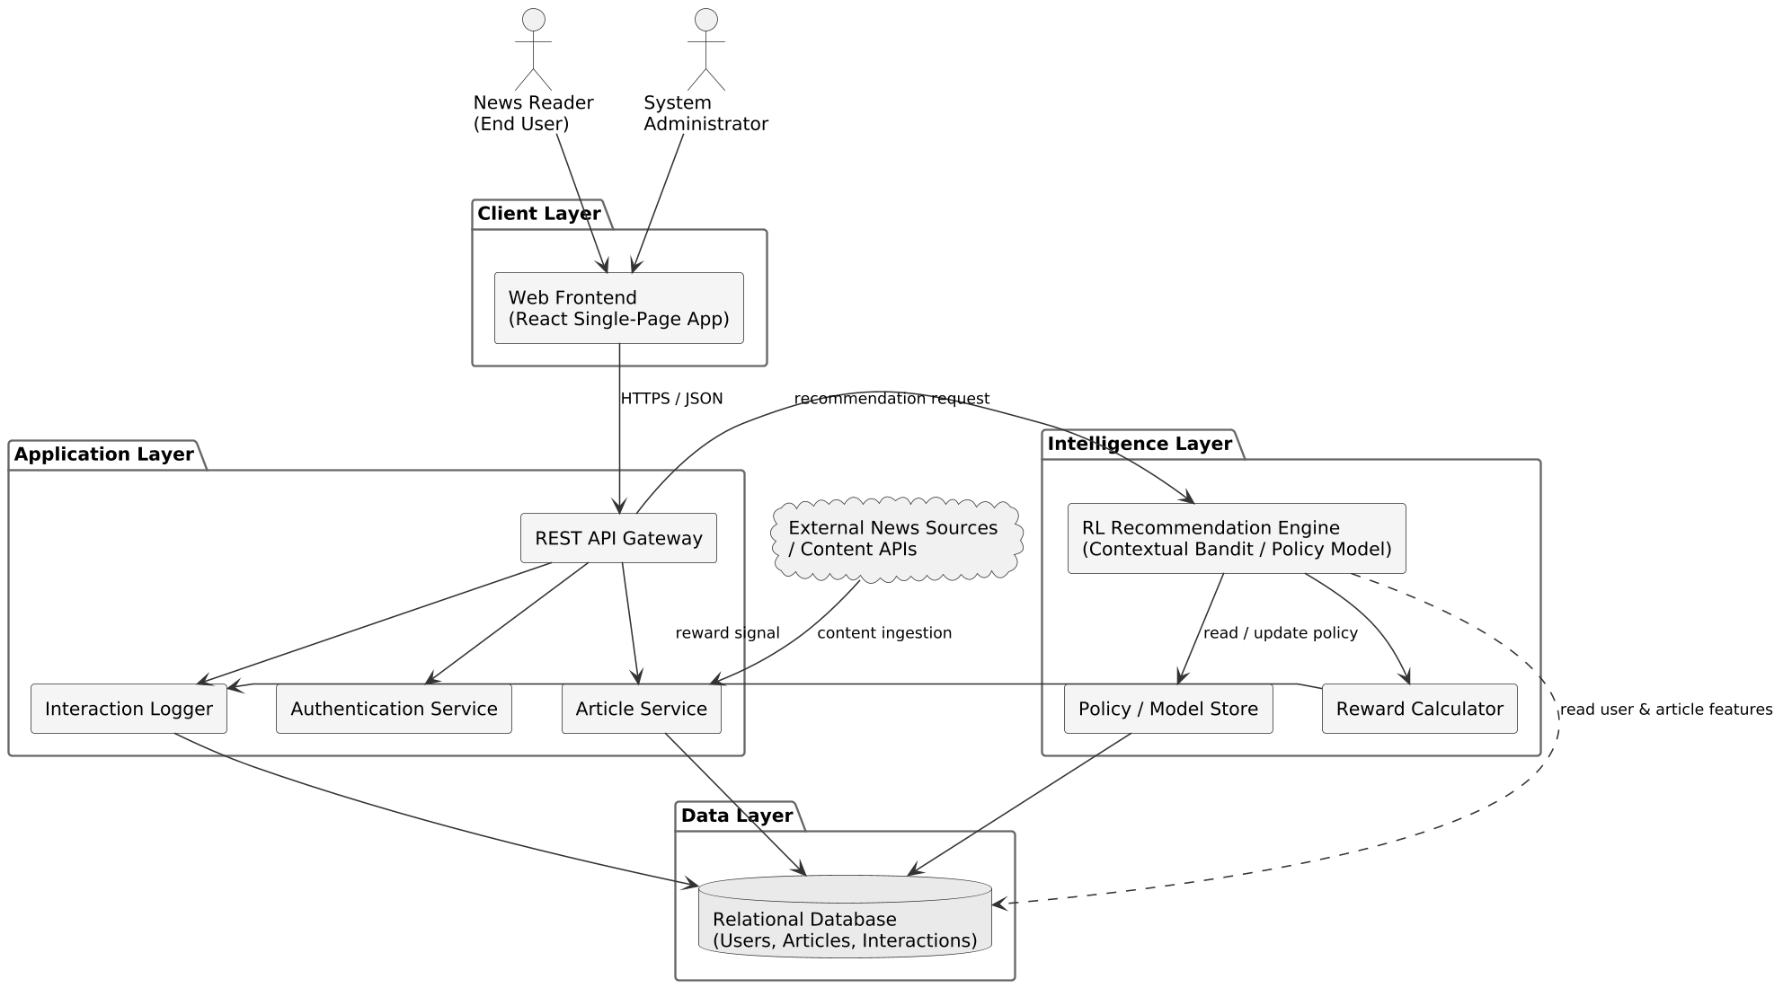

Figure 4.1: Proposed System Architecture

This architecture directly supports the adaptive behaviour central to the study's objectives (Section 1.3). Because the RL Recommendation Engine sits behind a well-defined internal interface (a recommendation request in, a ranked list of articles out; an interaction event in, a logged reward out), it can be retrained, replaced, or evaluated in a controlled online experiment [74] without requiring changes to the client application. Likewise, because the frontend communicates only through the REST API Gateway, new client features could be added without altering the recommendation engine. This architecture has been realised in the implemented prototype described in Sections 4.5 to 4.7, which follows the layer boundaries described here without material deviation.
4.3 Software Design
4.3.1 Software Design Tools
The design artefacts presented in this chapter were produced using standard software modelling notations (Unified Modelling Language use case, sequence, and activity diagrams, and entity-relationship notation for the data model [91]) so that the design remains tool-agnostic and can be verified against established software engineering practice [88]. The following tools were identified at design time to support the design and subsequent development of the system; the technologies finally adopted are listed in Section 4.13:
Category | Proposed Tool(s) | Purpose
Modelling / Diagramming | PlantUML / UML diagramming tools | Producing architecture, use case, sequence, activity, and data model diagrams
Backend Language & Framework | Python 3, Flask or FastAPI | Implementing the REST API Gateway and application services
Machine Learning / RL | scikit-learn, PyTorch, Gymnasium | Implementing and simulating the contextual bandit / RL policy model
Database | PostgreSQL (relational) | Persisting users, articles, interactions, and recommendation logs
Frontend | React (existing prototype) | Presenting the news feed and personalised recommendations to users
Version Control | Git | Source code management and change tracking
API Documentation / Testing | Postman / OpenAPI (Swagger) | Specifying and testing REST API endpoints

These tools are consistent with the Python-centred technology direction already established in Section 1.5 and Chapter 3, and they are widely adopted in both academic and industry recommender-system implementations, which reduces implementation risk for a final-year project of this scope.
4.3.2 Component Design
This section presents the detailed component-level design of the system using four complementary views: a use case model describing functional interactions between actors and the system; a sequence diagram describing the run-time flow of a single recommendation-and-feedback cycle; an activity diagram describing the continuous learning loop that is the core contribution of this project; and a data model describing the information persisted by the system. Together, these views were selected because each addresses a different design concern (behaviour, interaction, process, and data) without duplicating the others, in line with the requirement in Step 8 of the project brief that every diagram serve a distinct, well-defined purpose.
4.3.2.1 Use Case Model
Figure 4.2 presents the use case model for the system. Three actors interact with the system: the Reader (the primary end user), the System Administrator (responsible for content sources, user accounts, and system monitoring), and the RL Recommendation Engine itself, modelled as an actor because it autonomously generates recommendations and updates its policy independently of direct human instruction, consistent with its role as an adaptive, continuously learning component (Section 1.1).
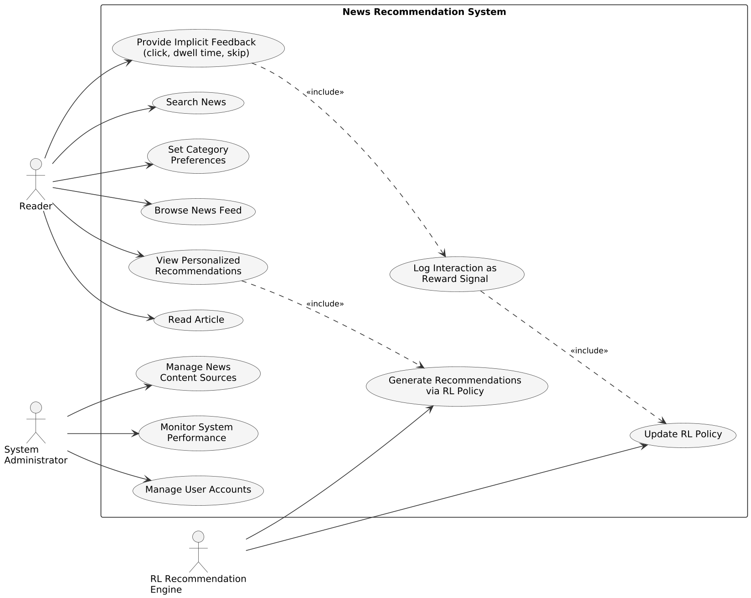

Figure 4.2: Use Case Diagram

The core reader-facing use cases are Browse News Feed, View Personalised Recommendations, Read Article, Search News, and Set Category Preferences. Provide Implicit Feedback is triggered whenever a reader clicks, reads, or skips an article, and it includes Log Interaction as Reward Signal, which in turn includes Update RL Policy: this include-relationship chain captures the closed-loop nature of the system, where every reader interaction ultimately feeds back into the model that generated the recommendation. View Personalised Recommendations includes Generate Recommendations via RL Policy, reflecting that recommendations are never static but are computed on demand from the current policy. Administrator-facing use cases (Manage News Content Sources, Monitor System Performance, and Manage User Accounts) support the operational, non-learning aspects of the system identified as functional requirements in Section 3.3.4.
All of these use cases have now been implemented. Implementation also added four reader-facing use cases that refine the original model: Choose Interests at sign-up (a specialisation of Set Category Preferences, Section 4.7.1), Like or Dislike Article (explicit feedback that, like implicit feedback, ultimately updates the reader's context, Section 4.9.1), View Trending Stories, and Read Article or Story Summary (Section 4.10).
4.3.2.2 Sequence Diagram
Figure 4.3 illustrates the run-time interaction sequence for a single recommendation-and-feedback cycle, involving the Reader, the Web Frontend, the API Gateway, the RL Recommendation Engine, and the Database.
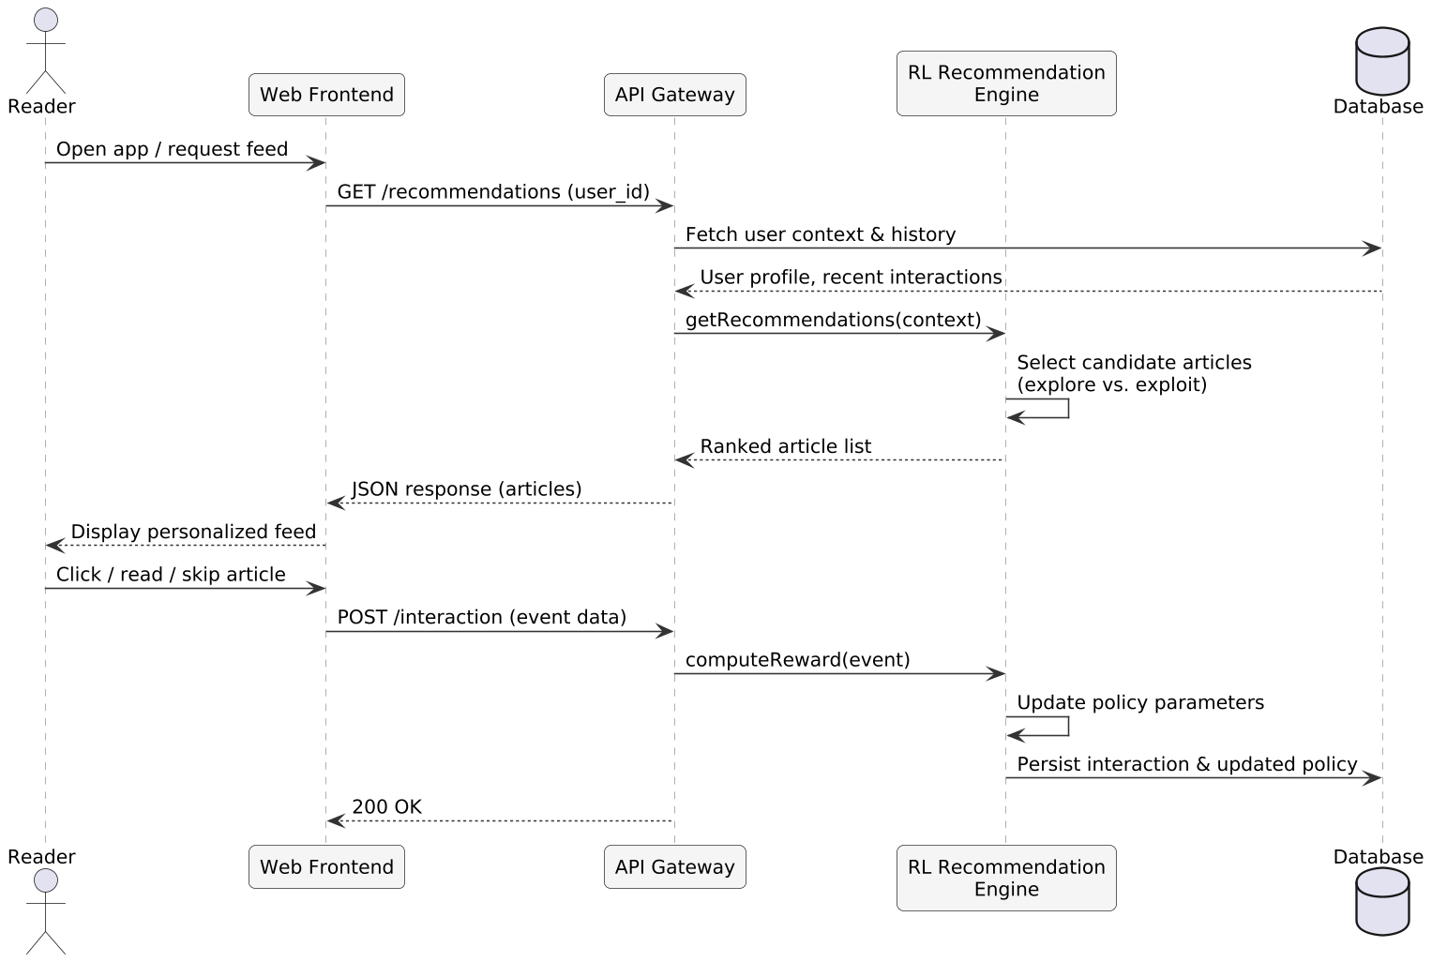

Figure 4.3: Sequence Diagram of the Recommendation and Feedback Cycle

When a reader opens the application, the frontend requests a personalised feed from the API Gateway, which first retrieves the reader's context (profile and recent interaction history) from the database. This context is passed to the RL Recommendation Engine, which selects a ranked list of candidate articles by balancing exploitation of known preferences against exploration of new or diverse content (Section 2.4). The ranked list is returned to the frontend and displayed to the reader. When the reader subsequently clicks, reads, or skips an article, the frontend reports this interaction event back to the API Gateway, which forwards it to the RL Recommendation Engine to compute a reward signal and update the policy parameters; the interaction and the updated policy state are then persisted to the database. This sequence repeats for every recommendation served, which is what allows the system to adapt within and across sessions rather than relying on a fixed, pre-trained model.
4.3.2.3 Activity Diagram
Whereas the sequence diagram describes a single request-response cycle between components, Figure 4.4 describes the continuous decision-feedback process from the perspective of the recommendation workflow itself, which is the central mechanism through which the system achieves adaptability (Research Question 2, Section 1.4).
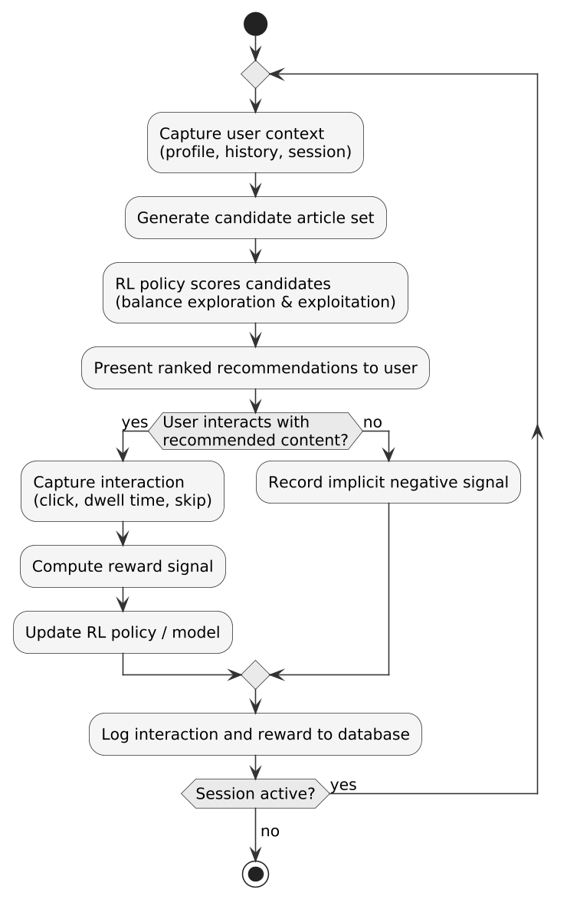

Figure 4.4: Activity Diagram of the Continuous Recommendation-Feedback Loop

The workflow begins by capturing the reader's current context, generating a set of candidate articles, and using the RL policy to score and rank them while balancing exploration and exploitation (Section 1.2). If the reader interacts with the recommended content, the interaction is captured, a reward is computed, and the policy is updated accordingly; if not, this is treated as an implicit negative signal. In either case, the event is logged to the database, and the loop repeats for as long as the session remains active. This design ensures that the model is never static: every recommendation served is itself an opportunity to learn, directly addressing the exploration-exploitation dilemma and the delayed-adaptation problem identified in Section 1.2.
4.3.2.4 Data Model (Entity-Relationship Diagram)
Because the proposed system is fundamentally data-driven, rather than object-oriented in the traditional sense, its structural design is expressed as an entity-relationship diagram (Figure 4.5) [91] rather than a UML class diagram. This choice keeps the structural design aligned with the CRISP-DM data understanding and data preparation phases discussed in Section 3.2, and it maps directly onto the relational database design presented in Section 4.4.
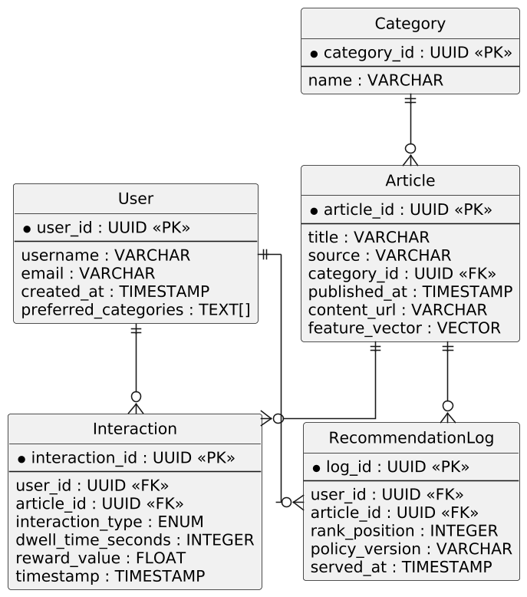

Figure 4.5: Entity-Relationship Diagram

Five core entities are identified in the original design. A User has many Interactions and appears in many RecommendationLog entries. An Article belongs to one Category, has many Interactions, and appears in many RecommendationLog entries. Interaction records capture the reward-relevant behaviour (event type, dwell time, and computed reward value) that drives learning, while RecommendationLog records what was actually shown to a user, in what position, and with what policy score, which is essential for the evaluation methodology described in Section 4.9. During implementation the model was extended with three further entities that are not drawn in Figure 4.5: UserInterest (the categories a reader selects during onboarding, Section 4.7.1), ArticleFeedback (explicit likes and dislikes, Section 4.9.1) and Summary (cached article and story summaries, Section 4.10.3).
4.4 Database Design
Table 4.1 summarises the relational schema as actually implemented in PostgreSQL [92] through the schema-migration tool identified in Section 4.6. A relational database was selected over a purely document-oriented store because the relationships between users, articles, and interactions are well-defined and benefit from the referential integrity of the relational model [93]. Six migrations have been applied to date: the initial schema, followed by migrations adding interest onboarding, article region and source, a full-text search index, article feedback, and article summaries.
Entity | Key Fields | Description
User | id (PK), name, email (unique), password_hash, is_admin, created_at, onboarded_at | Registered readers and administrators
Category | id (PK), slug (unique), name | The six news categories (bandit arms)
Article | id (PK), external_id, title, description, content, url, image_url, source_name, source_key, region, category, published_at, full_text, impressions, clicks, total_dwell_seconds | News articles ingested from live sources
Interaction | id (PK), user_id (FK), article_id (FK), event_type (impression, click, read), dwell_seconds, position, reward, created_at | Implicit reader behaviour and the computed reward
RecommendationLog | id (PK), user_id (FK), article_id (FK), category, score, position, created_at | Record of what was recommended, in which position and with what score
UserInterest | id (PK), user_id (FK), category, created_at | Categories chosen by the reader during onboarding
ArticleFeedback | id (PK), user_id (FK), article_id (FK), value (+1 like, −1 dislike), created_at, updated_at | Explicit likes and dislikes
Summary | id (PK), cache_key (unique), kind (article or story), article_ids, engine, payload, created_at | Cached article and story summaries

The RecommendationLog table exists independently of the Interaction table so that non-interactions (articles shown but not clicked) remain visible for evaluation purposes; without this record, it would be impossible to distinguish "not recommended" from "recommended but ignored," both of which carry different implications for the reward function described in Section 4.8. Two simplifications relative to the original design should be noted. First, articles store their category as a slug referencing the Category table's unique slug rather than a numeric foreign key, which keeps the bandit's arms and the stored articles in exactly the same vocabulary. Second, the policy_version field proposed for RecommendationLog has not been implemented; the log currently records the category (arm), score and position of each served article. Adding model versioning, so that every logged recommendation can be traced to the model state that produced it, is identified as further work.
4.5 Frontend Design and Implementation
The Client Layer described in Section 4.2 has been implemented, rather than merely proposed, as a single-page application built with React 19, bootstrapped using Vite and styled with Tailwind CSS 4, with client-side navigation handled by React Router 7, HTTP requests made through axios, and the analytics charts drawn with Recharts. This combination was chosen for its short development cycle and because it allows each view to be built as a small, independently testable component.
The implemented views are as follows. A public home page shows logged-out visitors trending stories and the latest headlines. Registration and login views consume the authentication endpoints described in Section 4.6 and store the resulting access token for subsequent requests. Immediately after registration, an onboarding view asks the reader which of the six categories interest them (Section 4.7.1). The personalised For You feed requests a ranked list of articles from the recommendation endpoint and renders it as article cards showing the headline, source, category, region and publication time, each with like and dislike controls. The article-detail view opens with an in-app summary of the story (Section 4.10.3), records the reader's dwell time and click-through as interaction events (Section 4.9), and links to the publisher for the full article. Further views provide category browsing, full-text search, a trending-stories page with combined story briefings, a "Your feedback" page listing liked and disliked articles, and an administrative analytics dashboard showing per-category click-through, rewards, likes and dislikes and the status of each news source.
Client-side state, including the authenticated user's session and the currently displayed feed, is managed using React's built-in hooks and context API rather than a dedicated state-management library; this was judged sufficient given the current scope of the prototype. An automated frontend test suite has not yet been undertaken and is identified as further work rather than claimed as complete.
4.6 Backend Design and Implementation
The Application Layer has been implemented in Python 3 using the Flask framework, exposing a REST API whose endpoint groups correspond directly to the component boundaries shown in Figure 4.1. SQLAlchemy is used as the object-relational mapper translating the entities of Figure 4.5 and Table 4.1 into PostgreSQL tables, and Flask-Migrate, built on Alembic, manages schema migrations. The migration command (flask db upgrade) has been executed successfully against a live PostgreSQL instance, creating the tables summarised in Table 4.1; this is reported as work that has actually been carried out and verified, not as a planned step.
Authentication is implemented using Flask-JWT-Extended, which issues a signed JSON Web Token [94] on successful login and requires that token on all endpoints that read or write reader-specific data. Access rules are enforced on the server rather than only in the user interface: anonymous visitors may list, search and browse headlines and teasers, but the full article, its publisher link and its summary are returned only to signed-in readers; the personalised feed additionally requires the reader to have selected at least one interest; and only signed-in readers' interactions are recorded, so that anonymous traffic never enters the reward signal. An administrator account and a body of synthetic interaction records, described in Section 4.9, support the verification activity described in Section 4.12 in the absence of a live user base.
The API is organised into the following endpoint groups: authentication (registration, login, token refresh); users (reading and updating a reader's interests and listing their feedback); articles and categories (listing, filtering by region, source and category, retrieving a single article, and recording likes and dislikes); recommendations (invoking the recommendation engine described in Section 4.7 for the authenticated reader's current context); interactions (recording impression, click and read events with dwell time); discovery (search, trending stories and summaries, Section 4.10); news sources (listing source status and, for administrators, triggering a refresh); and administrative analytics. The interactions endpoint is the point at which implicit reader feedback enters the system, and it is the raw material from which the reward signal used in reinforcement-learning training (Section 4.8) is computed.
4.7 Recommendation Engine Design and Implementation
The recommendation engine sits at the boundary between the backend and the reinforcement-learning model. On each request it builds a context describing the requesting reader from their stored interaction history: for each of the six categories it computes the reader's Laplace-smoothed click-through rate, their average reward, the global click-through rate of the category and a recency measure, giving a 24-dimensional context vector built by the same feature module used in training, so that training and serving cannot silently diverge. This vector is passed to the trained policy loaded through Stable-Baselines3 [95], which returns a preference score for each category; the engine then allocates the feed's slots across categories and fills each slot with recent articles from that category that the reader has not disliked. The policy is loaded once per process and falls back to a popularity baseline if no trained model is present, so that the API remains available. The engine is implemented as a self-contained module so that the trained policy can be substituted with a random baseline or an oracle policy for the comparative evaluation reported in Section 4.9.
During manual testing of the implemented system with a newly created reader account possessing no interaction history, a defect was identified in which the recommended feed collapsed onto a single news category rather than presenting a varied set of articles. Inspection of the recommendation logs for that account traced the cause to the policy's near-deterministic output for the cold-start context: for a reader with no recorded history, the policy assigned almost all of its probability mass to a single category. This behaviour was corrected in two ways: the policy's category scores are mixed with a uniform distribution (an exploration rate of ε = 0.15), and a diversity-floor allocation rule guarantees every category at least one slot, with the remaining slots allocated in proportion to the mixed scores. This is consistent with established exploration strategies for bandit problems [23], [24] and with diversification techniques for recommendation lists [69], [71]. Re-inspection of the recommendation logs for the same test account after the fix confirmed that the collapse no longer occurred and that the feed presented articles drawn from multiple categories.
This account is included as part of the honest record of development requested for this chapter: the defect was a genuine engineering problem encountered while building the prototype, and its resolution, rather than a defect-free first implementation, is what is being reported. The specific values used for the exploration rate and the diversity floor were set empirically during this testing rather than through a systematic hyperparameter search, and tuning them more rigorously is identified as further work.
4.7.1 Interest Onboarding for New Readers
The diversity floor prevents a collapsed feed but does not, on its own, personalise a new reader's first visit. To address the cold-start problem more directly [11], [59], every new account is now taken, immediately after registration, to an onboarding page on which the reader selects one or more of the six categories; the choices are stored in the UserInterest table and can be changed later from the feed. Stated interests are used in two ways. First, each chosen category is entered into the bandit context as if the reader had already seen it twice and clicked once; these pseudo-observations, analogous to an informative prior in Thompson sampling [51], give the trained policy a personalised context on the first request without any retraining or change to the feature schema, and they are progressively diluted as real impressions accumulate. Second, the category scores used to allocate slots are a blend of a stated-interest prior and the policy's output, score = w · prior + (1 − w) · policy, where w = K / (K + n), n is the number of the reader's real engagement events and K = 10. On a reader's first visit the feed is therefore driven almost entirely by what they said they wanted; as they engage, w falls toward zero and the learned policy takes over, so that actual behaviour can override stated preferences.
To avoid turning the stated interests themselves into a filter bubble [20], [68], every interest category receives at least one slot and two further discovery slots are always given to the best-scoring categories the reader did not choose. In a manual check on the development data, a reader who selected Politics and Technology was first served five politics, five technology and two discovery articles; after about ten clicks and reads on Sports articles their feed shifted to five sports articles, with the remaining slots spread over the other categories, demonstrating adaptation beyond the onboarding choices. Because the personalised feed now requires a profile, onboarding cannot be skipped, so every personalised feed begins from a stated profile rather than an anonymous cold start.
4.8 Reinforcement Learning Model Design
The recommendation problem is formalised within a custom environment built on the Gymnasium interface [96]. The observation is the 24-dimensional context vector described in Section 4.7 (four features for each of the six categories); the action is the choice of one category (arm) to serve; and the reward, computed identically in simulation and in the live system, is 1.0 for a click plus up to a further 0.5 for reading time, scaled linearly and capped at two minutes of dwell. The Proximal Policy Optimization algorithm [49], as implemented in Stable-Baselines3 [95] on top of PyTorch [97], is used to train the policy, a two-layer multilayer perceptron of 64 units per layer, with a learning rate of 0.001, 512 steps per update, mini-batches of 64 and an entropy coefficient of 0.01.
The initial version of the environment used single-step episodes, in which each episode consisted of exactly one recommendation decision before resetting, an arrangement intended to approximate the contextual-bandit formulation established by Li et al. [17] for personalised article recommendation. In this configuration, however, training logs showed negligible improvement in reward over time: with an episode terminating after a single step, every observation was the uninformative all-zero context of a brand-new reader, leaving the policy nothing to condition on. The environment was consequently redesigned so that each episode represents a simulated reader session of twenty sequential recommendation rounds, during which the reader's context evolves as interactions accumulate. Crucially, the discount factor is set to zero (γ = 0), so that PPO optimises each round's immediate reward independently; under this setting the method reduces to policy-gradient learning for a contextual bandit [24], [48], preserving the bandit formulation chosen in Chapter 2 while using the RL toolkit named in the methodology. Related applications of reinforcement learning and policy-gradient methods to recommendation are surveyed in [16], [57]. This redesign, and the defect that motivated it, are reported here as part of the honest account of development this chapter is required to give.
Following the redesign, the PPO agent was trained for 150,000 timesteps against the session-based environment. Training logs recorded the mean episode reward rising from approximately 4 at the start of training to approximately 8 by its conclusion, indicating that the policy was learning a measurably better recommendation strategy than its untrained starting point. This training run, and the log evidence it produced, are real and reproducible outputs of work already carried out on the prototype, not projected or assumed results.
The reward function itself measures engagement only; exploration and diversity are deliberately handled at serving time (Section 4.7) rather than being folded into the reward, so that the trained policy remains an estimate of what each reader is likely to engage with. The simulated readers used for training each have a hidden preference distribution over categories sampled from a Dirichlet distribution, from which click probabilities and dwell times are drawn. The theoretical grounding for the exploration-exploitation balance applied on top of the learned policy follows standard treatments of the multi-armed and contextual bandit problem [23], [24].
4.9 User Interaction, Feedback Mechanism, and Evaluation
Implicit reader feedback is captured through the Interaction and RecommendationLog tables introduced in Section 4.3.2.4 and summarised in Table 4.1. Every recommendation served to a reader is written to the RecommendationLog table regardless of whether the reader subsequently acts on it, while impressions, clicks and reads (with dwell time) are written to the Interaction table together with the computed reward; together these two tables allow both positive and negative evidence to be reconstructed, which is essential for computing the reward signal described in Section 4.8. Clicks and dwell time are well-established but noisy indicators of interest [61], [62], which motivated the addition of the explicit feedback channel described in Section 4.9.1.
Because the prototype has not yet been exposed to a live user base, a synthetic interaction dataset of 948 rows was generated using a scripted behaviour simulator and seeded into the database to provide the volume of feedback data needed to train and evaluate the recommendation policy. This dataset is explicitly synthetic, produced to exercise the pipeline end to end and to support the offline evaluation described below, and it is not presented as evidence of real reader behaviour.
Using the simulator, an offline evaluation was carried out comparing three policies over 300 held-out simulated sessions of twenty rounds each (reproducible with the command python -m rl.evaluate): a random baseline policy, which achieved a mean reward of approximately 0.20 per recommendation; the trained PPO policy described in Section 4.8, which achieved a mean reward of approximately 0.35 to 0.39; and an oracle policy that always serves each simulated reader's truly preferred category, which achieved approximately 0.57. The trained policy therefore captures roughly half of the improvement over random that is achievable in this environment. This comparison indicates that the trained policy performs substantially better than random recommendation and constitutes initial, genuine evidence toward the third research objective concerning the effectiveness of the adaptive recommendation approach. Because it is measured in simulation, it should be read as a check that the learning pipeline works rather than as a prediction of real-reader engagement; logged-data methods for unbiased offline evaluation of bandit policies [52] would be the natural next step once real interaction logs exist.
This evaluation is deliberately reported within its actual scope. Standard recommender-system metrics such as Precision@K, Recall@K and NDCG@K [72], [73], computed against an established benchmark dataset such as MIND [45], have not yet been computed, nor has the trained policy been compared directly against content-based or collaborative-filtering baselines. No live user study has been conducted, and consequently no engagement, diversity or adaptability measurements from real readers currently exist. These items are identified explicitly as necessary further work before the third research objective can be considered fully addressed, rather than being implied to have already been completed.
4.9.1 Explicit Feedback: Likes and Dislikes
Because implicit signals are ambiguous [61], signed-in readers can also give an explicit thumbs-up or thumbs-down on any article card and on the article page; these are stored in the ArticleFeedback table, one row per reader per article, and listed on a "Your feedback" page. Explicit feedback is weighted more heavily than implicit feedback [63]: in the bandit context each like counts as two impressions, two clicks and a reward of 1.0 in that category, and each dislike as two impressions with no click and a reward of −1.0, with the average-reward feature clamped to the range [0, 1] seen during training. This moves the same features the policy was trained on, so explicit feedback steers the trained policy without retraining, in line with work showing the value of negative feedback for recommendation [53]. A disliked article is never recommended to that reader again, likes and dislikes count as engagement and so hasten the hand-over from stated interests to the learned policy (Section 4.7.1), and the administrative dashboard reports likes and dislikes per category alongside each arm's click-through rate.
4.10 News Ingestion and Content Services
In the earlier version of the prototype, article content was drawn from a bundled offline dataset. This has since been replaced by live ingestion, which was identified as future work in the previous revision of this chapter. The system now ingests articles from 34 configured sources: 24 international feeds (including BBC News and BBC Sport, Al Jazeera, The Guardian, DW, France 24, Sky News, NPR, UN News, the World Health Organization, TechCrunch, The Verge, ESPN, Africanews and TechCabal) and 10 Zambian outlets (Lusaka Times, Zambia Daily Mail, Times of Zambia, Zambia Monitor, ZNBC, allAfrica's Zambia feed, News Diggers, Mwebantu, Zambian Observer and Daily Nation Zambia). All of these are read from public RSS feeds; CNN, which no longer maintains its RSS feeds, is read through the NewsAPI.org service when an API key is configured.
A background refresher fetches every source when the backend starts and every 30 minutes thereafter, and an administrator can also trigger a refresh from the analytics dashboard. Each feed is fetched independently so that one failing site never blocks the others, and the last result for each source is recorded and displayed. Articles older than seven days are skipped and duplicates are removed by URL. Single-topic feeds (for example BBC Technology) are mapped directly to a category, while general feeds are classified by a transparent keyword scorer that also uses the publisher's own RSS category tags; this keeps every article within the six categories the trained bandit already knows, so live ingestion required no retraining. Articles from Zambian outlets, and international stories that clearly concern Zambia, are tagged with a zambia region so that readers can filter both the feed and search results to local news; the bandit still chooses the topic mix while the region filter restricts the candidate articles. If no source can be reached and the database holds no live articles, the bundled sample articles are loaded instead so that the system remains demonstrable offline.
4.10.1 Full-Text Search
Search is implemented with PostgreSQL's built-in full-text search over article headlines and descriptions, supported by a GIN index. English stemming [75] allows a query for "flood" to match "floods" and "flooding"; results are ranked by a text-relevance score in which headline matches count double, blended with article freshness so that an older match does not outrank today's news [35], [76]. Quoted phrases, excluded terms and OR queries are supported, results can be filtered by region and category, and if no word matches the system falls back to a case-insensitive substring match so that partial names still return results.
4.10.2 Trending Stories
A trending service identifies the stories most widely covered across outlets in the previous 48 hours. Headlines that share key terms and at least one named person or place are grouped into a story; each story is scored by the number of distinct outlets covering it, with additional weight for breaking-news terms (such as deaths, earthquakes, floods and attacks) and for recent reader clicks, and the score decays with a 12-hour half-life, a simple form of the burst detection discussed in Section 2.2.7 [77]. Trending is a deterministic popularity signal that sits alongside, not inside, the bandit, but clicks on trending stories are logged like any other interaction and therefore still feed the reward signal; comparing this global popularity signal with the personalised policy is a natural element of the evaluation chapter.
4.10.3 In-App Article and Story Summaries
Rather than only linking out to the publisher, each article page opens with a readable summary, and trending stories offer a briefing that combines coverage from several outlets. Related coverage is found with the same headline-matching rules as the trending service, supplemented by a cosine-similarity check over story words, with at most one article per outlet and six in total. The main text of each publisher page is downloaded once and extracted with Trafilatura [84], stored server-side and never sent to the browser; paywalled or blocked pages fall back to the feed text. Summarisation is hybrid. When a Google Gemini API key is configured, a large language model writes a neutral summary, three to five key points and a short "why it matters" note, instructed to use only facts present in the sources and to name the outlet when only one source reports something, a mitigation for the hallucination risk of abstractive summarisation [82], [83]. Without a key, or if the API fails, an offline extractive summariser selects the most central sentences using a word-frequency centroid with a bonus for lead position [78], [81], and penalises sentences that repeat what has already been selected, a simplified form of maximal marginal relevance [70]. Summaries are cached in the Summary table, keyed by engine and the exact set of articles, and the top trending stories are summarised in advance after each refresh.
4.11 System Workflow
The overall workflow implemented in the prototype begins when a visitor registers, chooses their interests on the onboarding page, and receives a signed access token. On requesting their feed, the frontend calls the recommendations endpoint, which invokes the recommendation engine described in Section 4.7; the engine combines the stated-interest prior with the trained policy, applies the exploration and diversity mechanisms, and returns a ranked list of articles drawn from the continuously refreshed article store (Section 4.10). As the reader clicks, reads, likes or dislikes articles, the frontend reports these events to the interactions and feedback endpoints, which write them to the database; on the next request they immediately change the reader's context, and hence their feed, without retraining. The accumulated interaction data can subsequently be used, in an offline training run rather than a continuous online loop at the present stage of development, to retrain and re-evaluate the policy as described in Section 4.8.
This workflow corresponds directly to the sequence diagram in Figure 4.3 and the activity diagram in Figure 4.4 presented in Section 4.3.2; both diagrams have been confirmed, through the manual end-to-end testing summarised in Section 4.12, to describe the behaviour that the implemented prototype actually exhibits, rather than a workflow that remains only on paper.
4.12 Development Environment and Verification Status
Development and testing of the prototype have been carried out on a Windows-based development machine, using Python 3 for the backend and reinforcement-learning components and Node.js for the frontend build tooling, against a locally installed PostgreSQL server. The database schema was created by executing the Flask-Migrate upgrade command, categories were seeded, articles were ingested from the live sources described in Section 4.10, and an administrator account and the synthetic interaction records described in Section 4.9 were added through command-line tasks. The presence and structure of the tables, and the row counts inserted, were confirmed by direct inspection of the running database using the psql command-line client.
Verification of the prototype's behaviour has, at this stage, been conducted manually rather than through an automated test suite: the frontend flows described in Section 4.5 were exercised by hand, the database state was checked directly as described above, and the reinforcement-learning training and evaluation runs described in Sections 4.8 and 4.9 were inspected through their logged output. No unit or integration test suite has yet been written for either the backend or the frontend, and constructing one is identified plainly as further work rather than claimed to already exist.
The prototype currently runs only on the development machine described above. Containerised packaging or deployment to a cloud environment has not been attempted, consistent with the scope of a final-year prototype set out in Section 1.5, and remains a target for work beyond the present dissertation.
4.13 Technology Stack
Table 4.2 consolidates the technologies actually used to build the prototype described in this chapter, organised by the architectural layer introduced in Section 4.2. It is presented separately from the design-tool listing in Section 4.3.1 to distinguish the modelling tools used to produce the diagrams in this chapter from the technologies used to implement the running system itself.
Layer / Component | Technology | Role in the Implemented System
Client Layer | React 19, Vite, Tailwind CSS 4 | Single-page frontend application; implemented and running (Section 4.5)
Client Layer | React Router 7, axios, Recharts | Client-side navigation, API calls, and analytics charts
Application Layer | Python 3, Flask | REST API implementing the endpoint groups described in Section 4.6
Application Layer | SQLAlchemy, Flask-Migrate (Alembic) | Object-relational mapping and schema migration; six migrations applied to PostgreSQL
Application Layer | Flask-JWT-Extended [94] | Token-based authentication for protected endpoints
Data Layer | PostgreSQL [92] | Relational data store implementing the schema in Table 4.1, including full-text search
RL / Recommendation Layer | Gymnasium [96] | Custom environment formalising the recommendation problem (Section 4.8)
RL / Recommendation Layer | Stable-Baselines3, PPO, PyTorch [49], [95], [97] | Training algorithm and implementation for the recommendation policy
RL / Recommendation Layer | NumPy, pandas, scikit-learn | Feature computation, synthetic interaction simulation, offline evaluation (Section 4.9)
Data Ingestion | feedparser (RSS), NewsAPI.org, Trafilatura [84] | Live ingestion from 34 international and Zambian sources and full-text extraction (Section 4.10)
Summarisation | Google Gemini API (optional), offline extractive summariser | Hybrid article and story summaries (Section 4.10.3)
Tooling | Git | Version control of source code throughout development

Every entry in Table 4.2 corresponds to a technology that has been installed, configured and exercised during development, as opposed to one considered only as an alternative during design; where a tool was evaluated but not adopted, that consideration is confined to the discussion in Section 4.3.1 and is not repeated here. The numerical libraries NumPy [98], pandas [99] and scikit-learn [100] support feature computation, simulation and evaluation.
4.14 Chapter Summary
This chapter has presented both the design and the development progress achieved on the Reinforcement Learning-based Adaptive News Recommendation Engine. It described the layered system architecture, the software design artefacts produced during modelling, and the database design, before reporting, layer by layer, how the frontend, backend, recommendation engine and reinforcement-learning model have actually been built, including two genuine engineering defects encountered during development and the fixes applied to resolve them. It further reported the implicit and explicit feedback mechanisms, interest-based onboarding for new readers, live ingestion of international and Zambian news, the search, trending and summarisation services, the end-to-end system workflow, the development environment in which the prototype was built and verified, and the technology stack actually in use.
Considered against the three research objectives set out in Chapter 1, the chapter contributes as follows. The first objective, analysing the limitations of existing recommendation approaches, is addressed principally in Chapter 2 and is reflected in the design decisions justified throughout this chapter, particularly the exploration, diversity and discovery mechanisms adopted to mitigate the filter-bubble effect discussed in the literature [20], [68]. The second objective, designing and developing an adaptive reinforcement-learning-based recommendation model for local and international news, has been substantially addressed: the model has been designed, implemented and trained, it now serves live Zambian and international content, and it adapts to both implicit and explicit feedback, with reproducible evidence of learning reported in Section 4.8. The third objective, evaluating the effectiveness of the proposed system in terms of accuracy, engagement, diversity and adaptability, has been partially addressed through the offline comparison against random and oracle baselines reported in Section 4.9; the standard benchmark metrics, baseline comparisons and live user evaluation still required to consider this objective fully met have been identified explicitly rather than assumed, and constitute the principal remaining work beyond the scope of this dissertation.
References
[1] N. Newman, R. Fletcher, K. Eddy, C. T. Robertson, and R. K. Nielsen, “Reuters Institute Digital News Report 2023,” Reuters Institute for the Study of Journalism, University of Oxford, Oxford, U.K., 2023.
[2] N. Newman, R. Fletcher, C. T. Robertson, A. Ross Arguedas, and R. K. Nielsen, “Reuters Institute Digital News Report 2024,” Reuters Institute for the Study of Journalism, University of Oxford, Oxford, U.K., 2024.
[3] D. Bawden and L. Robinson, “The dark side of information: Overload, anxiety and other paradoxes and pathologies,” J. Inf. Sci., vol. 35, no. 2, pp. 180–191, 2009, doi: 10.1177/0165551508095781.
[4] M. J. Eppler and J. Mengis, “The concept of information overload: A review of literature from organization science, accounting, marketing, MIS, and related disciplines,” Inf. Soc., vol. 20, no. 5, pp. 325–344, 2004, doi: 10.1080/01972240490507974.
[5] M. Skovsgaard and K. Andersen, “Conceptualizing news avoidance: Towards a shared understanding of different causes and potential solutions,” Journalism Stud., vol. 21, no. 4, pp. 459–476, 2020, doi: 10.1080/1461670X.2019.1686410.
[6] A. S. Das, M. Datar, A. Garg, and S. Rajaram, “Google news personalization: Scalable online collaborative filtering,” in Proc. 16th Int. Conf. World Wide Web (WWW), 2007, pp. 271–280, doi: 10.1145/1242572.1242610.
[7] P. Covington, J. Adams, and E. Sargin, “Deep neural networks for YouTube recommendations,” in Proc. 10th ACM Conf. Recommender Syst. (RecSys), 2016, pp. 191–198, doi: 10.1145/2959100.2959190.
[8] C. A. Gomez-Uribe and N. Hunt, “The Netflix recommender system: Algorithms, business value, and innovation,” ACM Trans. Manage. Inf. Syst., vol. 6, no. 4, pp. 1–19, 2015, doi: 10.1145/2843948.
[9] M. Karimi, D. Jannach, and M. Jugovac, “News recommender systems – Survey and roads ahead,” Inf. Process. Manage., vol. 54, no. 6, pp. 1203–1227, 2018, doi: 10.1016/j.ipm.2018.04.008.
[10] G. Adomavicius and A. Tuzhilin, “Toward the next generation of recommender systems: A survey of the state-of-the-art and possible extensions,” IEEE Trans. Knowl. Data Eng., vol. 17, no. 6, pp. 734–749, 2005, doi: 10.1109/TKDE.2005.99.
[11] A. I. Schein, A. Popescul, L. H. Ungar, and D. M. Pennock, “Methods and metrics for cold-start recommendations,” in Proc. 25th Annu. Int. ACM SIGIR Conf. Res. Develop. Inf. Retrieval, 2002, pp. 253–260, doi: 10.1145/564376.564421.
[12] Y. Koren, “Collaborative filtering with temporal dynamics,” Commun. ACM, vol. 53, no. 4, pp. 89–97, 2010, doi: 10.1145/1721654.1721677.
[13] R. S. Sutton and A. G. Barto, Reinforcement Learning: An Introduction, 2nd ed. Cambridge, MA, USA: MIT Press, 2018.
[14] V. Mnih et al., “Human-level control through deep reinforcement learning,” Nature, vol. 518, no. 7540, pp. 529–533, 2015, doi: 10.1038/nature14236.
[15] G. Zheng, F. Zhang, Z. Zheng, Y. Xiang, N. J. Yuan, X. Xie, and Z. Li, “DRN: A deep reinforcement learning framework for news recommendation,” in Proc. World Wide Web Conf. (WWW), Lyon, France, 2018, pp. 167–176, doi: 10.1145/3178876.3185994.
[16] M. M. Afsar, T. Crump, and B. Far, “Reinforcement learning based recommender systems: A survey,” ACM Comput. Surv., vol. 55, no. 7, pp. 1–38, 2022, doi: 10.1145/3543846.
[17] L. Li, W. Chu, J. Langford, and R. E. Schapire, “A contextual-bandit approach to personalized news article recommendation,” in Proc. 19th Int. Conf. World Wide Web (WWW), Raleigh, NC, USA, 2010, pp. 661–670, doi: 10.1145/1772690.1772758.
[18] S. Raza and C. Ding, “News recommender system: A review of recent progress, challenges, and opportunities,” Artif. Intell. Rev., vol. 55, no. 1, pp. 749–800, 2022, doi: 10.1007/s10462-021-10043-x.
[19] C. Wu, F. Wu, Y. Huang, and X. Xie, “Personalized news recommendation: Methods and challenges,” ACM Trans. Inf. Syst., vol. 41, no. 1, pp. 1–50, 2023, doi: 10.1145/3530257.
[20] E. Pariser, The Filter Bubble: What the Internet Is Hiding from You. New York, NY, USA: Penguin Press, 2011.
[21] E. Bakshy, S. Messing, and L. A. Adamic, “Exposure to ideologically diverse news and opinion on Facebook,” Science, vol. 348, no. 6239, pp. 1130–1132, 2015, doi: 10.1126/science.aaa1160.
[22] S. Flaxman, S. Goel, and J. M. Rao, “Filter bubbles, echo chambers, and online news consumption,” Public Opinion Quart., vol. 80, no. S1, pp. 298–320, 2016, doi: 10.1093/poq/nfw006.
[23] P. Auer, N. Cesa-Bianchi, and P. Fischer, “Finite-time analysis of the multiarmed bandit problem,” Mach. Learn., vol. 47, no. 2–3, pp. 235–256, 2002, doi: 10.1023/A:1013689704352.
[24] T. Lattimore and C. Szepesvári, Bandit Algorithms. Cambridge, U.K.: Cambridge Univ. Press, 2020, doi: 10.1017/9781108571401.
[25] M. H. Ribeiro, R. Ottoni, R. West, V. A. F. Almeida, and W. Meira Jr., “Auditing radicalization pathways on YouTube,” in Proc. Conf. Fairness, Accountability, Transparency (FAT*), 2020, pp. 131–141, doi: 10.1145/3351095.3372879.
[26] S. Vosoughi, D. Roy, and S. Aral, “The spread of true and false news online,” Science, vol. 359, no. 6380, pp. 1146–1151, 2018, doi: 10.1126/science.aap9559.
[27] M. Walker and K. E. Matsa, “News consumption across social media in 2021,” Pew Research Center, Washington, DC, USA, Sep. 2021.
[28] F. Ricci, L. Rokach, and B. Shapira, Eds., Recommender Systems Handbook, 3rd ed. New York, NY, USA: Springer, 2022, doi: 10.1007/978-1-0716-2197-4.
[29] D. Goldberg, D. Nichols, B. M. Oki, and D. Terry, “Using collaborative filtering to weave an information tapestry,” Commun. ACM, vol. 35, no. 12, pp. 61–70, 1992, doi: 10.1145/138859.138867.
[30] P. Resnick, N. Iacovou, M. Suchak, P. Bergstrom, and J. Riedl, “GroupLens: An open architecture for collaborative filtering of netnews,” in Proc. ACM Conf. Comput. Supported Cooperative Work (CSCW), 1994, pp. 175–186, doi: 10.1145/192844.192905.
[31] P. Lops, M. de Gemmis, and G. Semeraro, “Content-based recommender systems: State of the art and trends,” in Recommender Systems Handbook, F. Ricci, L. Rokach, B. Shapira, and P. B. Kantor, Eds. Boston, MA, USA: Springer, 2011, pp. 73–105, doi: 10.1007/978-0-387-85820-3_3.
[32] R. Burke, “Hybrid recommender systems: Survey and experiments,” User Model. User-Adapted Interact., vol. 12, no. 4, pp. 331–370, 2002, doi: 10.1023/A:1021240730564.
[33] Y. Koren, R. Bell, and C. Volinsky, “Matrix factorization techniques for recommender systems,” Computer, vol. 42, no. 8, pp. 30–37, 2009, doi: 10.1109/MC.2009.263.
[34] G. Salton and C. Buckley, “Term-weighting approaches in automatic text retrieval,” Inf. Process. Manage., vol. 24, no. 5, pp. 513–523, 1988, doi: 10.1016/0306-4573(88)90021-0.
[35] C. D. Manning, P. Raghavan, and H. Schütze, Introduction to Information Retrieval. Cambridge, U.K.: Cambridge Univ. Press, 2008.
[36] D. Billsus and M. J. Pazzani, “User modeling for adaptive news access,” User Model. User-Adapted Interact., vol. 10, no. 2–3, pp. 147–180, 2000, doi: 10.1023/A:1026501525781.
[37] J. Liu, P. Dolan, and E. R. Pedersen, “Personalized news recommendation based on click behavior,” in Proc. 15th Int. Conf. Intell. User Interfaces (IUI), 2010, pp. 31–40, doi: 10.1145/1719970.1719976.
[38] S. Zhang, L. Yao, A. Sun, and Y. Tay, “Deep learning based recommender system: A survey and new perspectives,” ACM Comput. Surv., vol. 52, no. 1, pp. 1–38, 2019, doi: 10.1145/3285029.
[39] S. Okura, Y. Tagami, S. Ono, and A. Tajima, “Embedding-based news recommendation for millions of users,” in Proc. 23rd ACM SIGKDD Int. Conf. Knowl. Discovery Data Mining (KDD), Halifax, NS, Canada, 2017.
[40] H. Wang, F. Zhang, X. Xie, and M. Guo, “DKN: Deep knowledge-aware network for news recommendation,” in Proc. World Wide Web Conf. (WWW), 2018, pp. 1835–1844, doi: 10.1145/3178876.3186175.
[41] C. Wu, F. Wu, S. Ge, T. Qi, Y. Huang, and X. Xie, “Neural news recommendation with multi-head self-attention,” in Proc. Conf. Empirical Methods Natural Lang. Process. and 9th Int. Joint Conf. Natural Lang. Process. (EMNLP-IJCNLP), Hong Kong, China, 2019, pp. 6389–6394, doi: 10.18653/v1/D19-1671.
[42] M. An, F. Wu, C. Wu, K. Zhang, Z. Liu, and X. Xie, “Neural news recommendation with long- and short-term user representations,” in Proc. 57th Annu. Meeting Assoc. Comput. Linguistics (ACL), Florence, Italy, 2019, pp. 336–345, doi: 10.18653/v1/P19-1033.
[43] C. Wu, F. Wu, M. An, J. Huang, Y. Huang, and X. Xie, “NPA: Neural news recommendation with personalized attention,” in Proc. 25th ACM SIGKDD Int. Conf. Knowl. Discovery Data Mining (KDD), 2019, pp. 2576–2584, doi: 10.1145/3292500.3330665.
[44] C. Wu, F. Wu, T. Qi, and Y. Huang, “Empowering news recommendation with pre-trained language models,” in Proc. 44th Int. ACM SIGIR Conf. Res. Develop. Inf. Retrieval, 2021, pp. 1652–1656, doi: 10.1145/3404835.3463069.
[45] F. Wu, Y. Qiao, J.-H. Chen, C. Wu, T. Qi, J. Lian, D. Liu, X. Xie, J. Gao, W. Wu, and M. Zhou, “MIND: A large-scale dataset for news recommendation,” in Proc. 58th Annu. Meeting Assoc. Comput. Linguistics (ACL), 2020, pp. 3597–3606, doi: 10.18653/v1/2020.acl-main.331.
[46] M. Quadrana, P. Cremonesi, and D. Jannach, “Sequence-aware recommender systems,” ACM Comput. Surv., vol. 51, no. 4, pp. 1–36, 2018, doi: 10.1145/3190616.
[47] W.-C. Kang and J. McAuley, “Self-attentive sequential recommendation,” in Proc. IEEE Int. Conf. Data Mining (ICDM), 2018, pp. 197–206, doi: 10.1109/ICDM.2018.00035.
[48] R. J. Williams, “Simple statistical gradient-following algorithms for connectionist reinforcement learning,” Mach. Learn., vol. 8, no. 3–4, pp. 229–256, 1992, doi: 10.1007/BF00992696.
[49] J. Schulman, F. Wolski, P. Dhariwal, A. Radford, and O. Klimov, “Proximal policy optimization algorithms,” arXiv:1707.06347, 2017.
[50] W. R. Thompson, “On the likelihood that one unknown probability exceeds another in view of the evidence of two samples,” Biometrika, vol. 25, no. 3–4, pp. 285–294, 1933, doi: 10.1093/biomet/25.3-4.285.
[51] D. J. Russo, B. Van Roy, A. Kazerouni, I. Osband, and Z. Wen, “A tutorial on Thompson sampling,” Found. Trends Mach. Learn., vol. 11, no. 1, pp. 1–96, 2018, doi: 10.1561/2200000070.
[52] L. Li, W. Chu, J. Langford, and X. Wang, “Unbiased offline evaluation of contextual-bandit-based news article recommendation algorithms,” in Proc. 4th ACM Int. Conf. Web Search Data Mining (WSDM), 2011, pp. 297–306, doi: 10.1145/1935826.1935878.
[53] X. Zhao, L. Zhang, Z. Ding, L. Xia, J. Tang, and D. Yin, “Recommendations with negative feedback via pairwise deep reinforcement learning,” in Proc. 24th ACM SIGKDD Int. Conf. Knowl. Discovery Data Mining (KDD), 2018, pp. 1040–1048, doi: 10.1145/3219819.3219886.
[54] M. Chen, A. Beutel, P. Covington, S. Jain, F. Belletti, and E. H. Chi, “Top-K off-policy correction for a REINFORCE recommender system,” in Proc. 12th ACM Int. Conf. Web Search Data Mining (WSDM), 2019.
[55] E. Ie, V. Jain, J. Wang, S. Narvekar, R. Agarwal, R. Wu, H.-T. Cheng, T. Chandra, and C. Boutilier, “SlateQ: A tractable decomposition for reinforcement learning with recommendation sets,” in Proc. 28th Int. Joint Conf. Artif. Intell. (IJCAI), 2019, pp. 2592–2599, doi: 10.24963/ijcai.2019/360.
[56] L. Zou, L. Xia, Z. Ding, J. Song, W. Liu, and D. Yin, “Reinforcement learning to optimize long-term user engagement in recommender systems,” in Proc. 25th ACM SIGKDD Int. Conf. Knowl. Discovery Data Mining (KDD), 2019, pp. 2810–2818, doi: 10.1145/3292500.3330668.
[57] X. Chen, L. Yao, J. McAuley, G. Zhou, and X. Wang, “Deep reinforcement learning in recommender systems: A survey and new perspectives,” Knowl.-Based Syst., vol. 264, Art. no. 110335, 2023, doi: 10.1016/j.knosys.2023.110335.
[58] Y. Lin, Y. Liu, F. Lin, L. Zou, P. Wu, W. Zeng, H. Chen, and C. Miao, “A survey on reinforcement learning for recommender systems,” IEEE Trans. Neural Netw. Learn. Syst., vol. 35, no. 10, pp. 13164–13184, 2024, doi: 10.1109/TNNLS.2023.3280161.
[59] A. M. Rashid, I. Albert, D. Cosley, S. K. Lam, S. M. McNee, J. A. Konstan, and J. Riedl, “Getting to know you: Learning new user preferences in recommender systems,” in Proc. 7th Int. Conf. Intell. User Interfaces (IUI), 2002, pp. 127–134, doi: 10.1145/502716.502737.
[60] M. Elahi, F. Ricci, and N. Rubens, “A survey of active learning in collaborative filtering recommender systems,” Comput. Sci. Rev., vol. 20, pp. 29–50, 2016, doi: 10.1016/j.cosrev.2016.05.002.
[61] D. Kelly and J. Teevan, “Implicit feedback for inferring user preference: A bibliography,” ACM SIGIR Forum, vol. 37, no. 2, pp. 18–28, 2003, doi: 10.1145/959258.959260.
[62] X. Yi, L. Hong, E. Zhong, N. N. Liu, and S. Rajan, “Beyond clicks: Dwell time for personalization,” in Proc. 8th ACM Conf. Recommender Syst. (RecSys), 2014, pp. 113–120, doi: 10.1145/2645710.2645724.
[63] G. Jawaheer, P. Weller, and P. Kostkova, “Modeling user preferences in recommender systems: A classification framework for explicit and implicit user feedback,” ACM Trans. Interact. Intell. Syst., vol. 4, no. 2, pp. 1–26, 2014, doi: 10.1145/2512208.
[64] T. T. Nguyen, P.-M. Hui, F. M. Harper, L. Terveen, and J. A. Konstan, “Exploring the filter bubble: The effect of using recommender systems on content diversity,” in Proc. 23rd Int. Conf. World Wide Web (WWW), 2014, pp. 677–686, doi: 10.1145/2566486.2568012.
[65] J. Möller, D. Trilling, N. Helberger, and B. van Es, “Do not blame it on the algorithm: An empirical assessment of multiple recommender systems and their impact on content diversity,” Inf., Commun. Soc., vol. 21, no. 7, pp. 959–977, 2018, doi: 10.1080/1369118X.2018.1444076.
[66] F. J. Zuiderveen Borgesius, D. Trilling, J. Möller, B. Bodó, C. H. de Vreese, and N. Helberger, “Should we worry about filter bubbles?,” Internet Policy Rev., vol. 5, no. 1, 2016, doi: 10.14763/2016.1.401.
[67] A. J. B. Chaney, B. M. Stewart, and B. E. Engelhardt, “How algorithmic confounding in recommendation systems increases homogeneity and decreases utility,” in Proc. 12th ACM Conf. Recommender Syst. (RecSys), 2018, pp. 224–232, doi: 10.1145/3240323.3240370.
[68] N. Helberger, K. Karppinen, and L. D'Acunto, “Exposure diversity as a design principle for recommender systems,” Inf., Commun. Soc., vol. 21, no. 2, pp. 191–207, 2018, doi: 10.1080/1369118X.2016.1271900.
[69] C.-N. Ziegler, S. M. McNee, J. A. Konstan, and G. Lausen, “Improving recommendation lists through topic diversification,” in Proc. 14th Int. Conf. World Wide Web (WWW), 2005, pp. 22–32, doi: 10.1145/1060745.1060754.
[70] J. Carbonell and J. Goldstein, “The use of MMR, diversity-based reranking for reordering documents and producing summaries,” in Proc. 21st Annu. Int. ACM SIGIR Conf. Res. Develop. Inf. Retrieval, 1998, pp. 335–336, doi: 10.1145/290941.291025.
[71] M. Kaminskas and D. Bridge, “Diversity, serendipity, novelty, and coverage: A survey and empirical analysis of beyond-accuracy objectives in recommender systems,” ACM Trans. Interact. Intell. Syst., vol. 7, no. 1, pp. 1–42, 2016, doi: 10.1145/2926720.
[72] J. L. Herlocker, J. A. Konstan, L. G. Terveen, and J. T. Riedl, “Evaluating collaborative filtering recommender systems,” ACM Trans. Inf. Syst., vol. 22, no. 1, pp. 5–53, 2004, doi: 10.1145/963770.963772.
[73] K. Järvelin and J. Kekäläinen, “Cumulated gain-based evaluation of IR techniques,” ACM Trans. Inf. Syst., vol. 20, no. 4, pp. 422–446, 2002, doi: 10.1145/582415.582418.
[74] R. Kohavi, R. Longbotham, D. Sommerfield, and R. M. Henne, “Controlled experiments on the web: Survey and practical guide,” Data Mining Knowl. Discovery, vol. 18, no. 1, pp. 140–181, 2009, doi: 10.1007/s10618-008-0114-1.
[75] M. F. Porter, “An algorithm for suffix stripping,” Program, vol. 14, no. 3, pp. 130–137, 1980, doi: 10.1108/eb046814.
[76] S. Robertson and H. Zaragoza, “The probabilistic relevance framework: BM25 and beyond,” Found. Trends Inf. Retrieval, vol. 3, no. 4, pp. 333–389, 2009, doi: 10.1561/1500000019.
[77] J. Kleinberg, “Bursty and hierarchical structure in streams,” in Proc. 8th ACM SIGKDD Int. Conf. Knowl. Discovery Data Mining (KDD), 2002, pp. 91–101, doi: 10.1145/775047.775061.
[78] H. P. Luhn, “The automatic creation of literature abstracts,” IBM J. Res. Develop., vol. 2, no. 2, pp. 159–165, 1958, doi: 10.1147/rd.22.0159.
[79] G. Erkan and D. R. Radev, “LexRank: Graph-based lexical centrality as salience in text summarization,” J. Artif. Intell. Res., vol. 22, pp. 457–479, 2004, doi: 10.1613/jair.1523.
[80] R. Mihalcea and P. Tarau, “TextRank: Bringing order into text,” in Proc. Conf. Empirical Methods Natural Lang. Process. (EMNLP), Barcelona, Spain, 2004, pp. 404–411.
[81] A. Nenkova and K. McKeown, “A survey of text summarization techniques,” in Mining Text Data, C. C. Aggarwal and C. Zhai, Eds. Boston, MA, USA: Springer, 2012, pp. 43–76, doi: 10.1007/978-1-4614-3223-4_3.
[82] J. Maynez, S. Narayan, B. Bohnet, and R. McDonald, “On faithfulness and factuality in abstractive summarization,” in Proc. 58th Annu. Meeting Assoc. Comput. Linguistics (ACL), 2020, pp. 1906–1919, doi: 10.18653/v1/2020.acl-main.173.
[83] Z. Ji et al., “Survey of hallucination in natural language generation,” ACM Comput. Surv., vol. 55, no. 12, pp. 1–38, 2023, doi: 10.1145/3571730.
[84] A. Barbaresi, “Trafilatura: A web scraping library and command-line tool for text discovery and extraction,” in Proc. 59th Annu. Meeting Assoc. Comput. Linguistics and 11th Int. Joint Conf. Natural Lang. Process.: Syst. Demonstrations, 2021, pp. 122–131, doi: 10.18653/v1/2021.acl-demo.15.
[85] P. Chapman, J. Clinton, R. Kerber, T. Khabaza, T. Reinartz, C. Shearer, and R. Wirth, “CRISP-DM 1.0: Step-by-step data mining guide,” SPSS Inc., Chicago, IL, USA, 2000.
[86] C. Schröer, F. Kruse, and J. Marx Gómez, “A systematic literature review on applying CRISP-DM process model,” Procedia Comput. Sci., vol. 181, pp. 526–534, 2021, doi: 10.1016/j.procs.2021.01.199.
[87] T. Wambsganß, N. Molyndris, and M. Söllner, “Unlocking transfer learning in argumentation mining: A domain-independent modelling approach,” in Proc. 15th Int. Conf. Wirtschaftsinformatik (WI), Potsdam, Germany, Mar. 2020.
[88] I. Sommerville, Software Engineering, 10th ed. Harlow, U.K.: Pearson, 2016.
[89] Systems and Software Engineering — Systems and Software Quality Requirements and Evaluation (SQuaRE) — System and Software Quality Models, ISO/IEC Standard 25010:2011, 2011.
[90] R. T. Fielding, “Architectural styles and the design of network-based software architectures,” Ph.D. dissertation, Dept. Inf. Comput. Sci., Univ. California, Irvine, CA, USA, 2000.
[91] P. P.-S. Chen, “The entity-relationship model—Toward a unified view of data,” ACM Trans. Database Syst., vol. 1, no. 1, pp. 9–36, 1976, doi: 10.1145/320434.320440.
[92] M. Stonebraker and L. A. Rowe, “The design of POSTGRES,” in Proc. ACM SIGMOD Int. Conf. Manage. Data, 1986, pp. 340–355, doi: 10.1145/16894.16888.
[93] E. F. Codd, “A relational model of data for large shared data banks,” Commun. ACM, vol. 13, no. 6, pp. 377–387, 1970, doi: 10.1145/362384.362685.
[94] M. Jones, J. Bradley, and N. Sakimura, “JSON Web Token (JWT),” Internet Engineering Task Force, RFC 7519, May 2015, doi: 10.17487/RFC7519.
[95] A. Raffin, A. Hill, A. Gleave, A. Kanervisto, M. Ernestus, and N. Dormann, “Stable-Baselines3: Reliable reinforcement learning implementations,” J. Mach. Learn. Res., vol. 22, no. 268, pp. 1–8, 2021.
[96] M. Towers et al., “Gymnasium: A standard interface for reinforcement learning environments,” arXiv:2407.17032, 2024.
[97] A. Paszke et al., “PyTorch: An imperative style, high-performance deep learning library,” in Proc. Adv. Neural Inf. Process. Syst. (NeurIPS), vol. 32, 2019, pp. 8026–8037.
[98] C. R. Harris et al., “Array programming with NumPy,” Nature, vol. 585, no. 7825, pp. 357–362, 2020, doi: 10.1038/s41586-020-2649-2.
[99] W. McKinney, “Data structures for statistical computing in Python,” in Proc. 9th Python Sci. Conf. (SciPy), 2010, pp. 56–61, doi: 10.25080/Majora-92bf1922-00a.
[100] F. Pedregosa et al., “Scikit-learn: Machine learning in Python,” J. Mach. Learn. Res., vol. 12, pp. 2825–2830, 2011.
APPENDICES
Appendix A: Glossary of Terms
Term | Definition
Contextual Bandit | A simplified reinforcement learning setting in which an agent selects an action (here, a news category) based on context, receives a reward, but does not model transitions between states, unlike full sequential RL [13].
Cold Start Problem | The difficulty a recommendation system faces in generating accurate recommendations for new users or new items with little or no historical interaction data.
Exploration-Exploitation Trade-off | The balance a reinforcement learning agent must strike between exploiting known, high-reward actions and exploring new actions that may yield higher reward [13].
Filter Bubble | A state in which a user is algorithmically exposed to a narrow range of viewpoints or content due to personalisation, limiting exposure to diverse perspectives [20].
NDCG (Normalised Discounted Cumulative Gain) | An information-retrieval metric that measures ranking quality, giving more credit to relevant results appearing earlier in a ranked list [73].
Policy (RL) | The strategy a reinforcement learning agent uses to select actions given a context or state.
Reward Signal | A numerical value fed back to a reinforcement learning agent indicating how favourable an outcome (e.g., a user interaction) was.

Appendix B: Supplementary Materials (To Be Added by the Researcher)
This appendix is reserved for supplementary materials that support the study but are not reproduced in the main body of the report, for example: any requirements-gathering instruments actually used (survey or interview questions, per Section 3.3.2), full system source code listings or a link to the project repository, complete evaluation result sets and plots from further, larger-scale evaluation beyond the prototype-level results reported in Chapter 4, and any ethical clearance or consent documentation associated with user data collection. These materials should be attached by the researcher once available; none are fabricated or assumed here.

